Diatoms in Indiana Streams as

Indicators of Biological Condition

*Prepared for*

United States Environmental Protection Agency

Region 5

Chicago, IL

and

Indiana Department of Environmental Management

Indianapolis, IN

*Prepared by*

Ben Jessup, Ben Block, Jen Stamp, and Erik Leppo

Tetra Tech

Montpelier, VT

Final Report

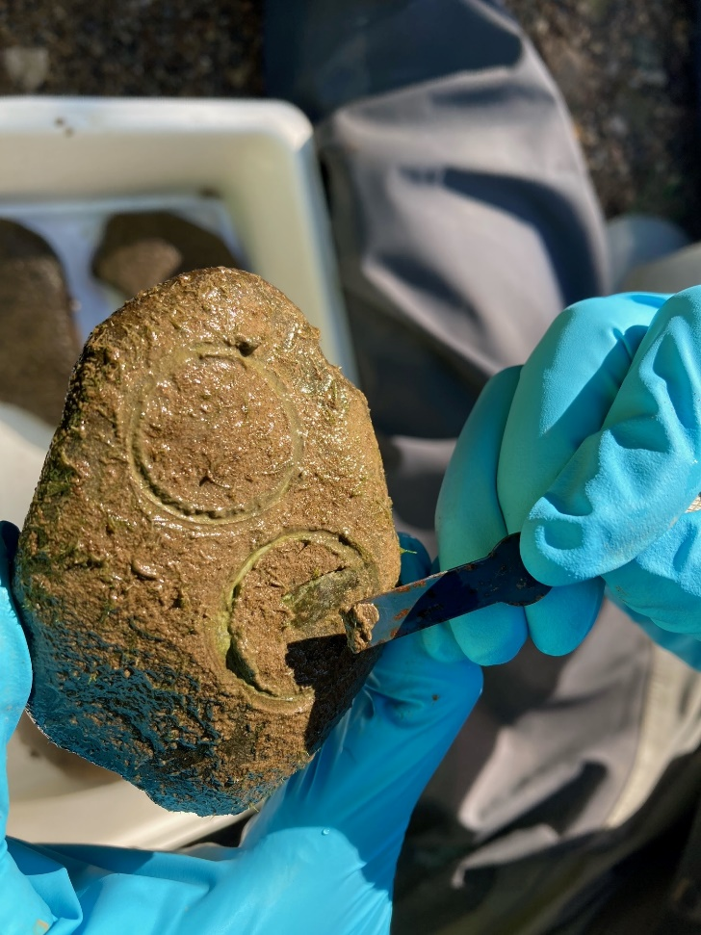October 12, 2021



# Executive Summary

***Background and Purpose***

The Indiana Department of Environmental Management’s (IDEM) mission statement includes an objective to implement federal and state regulations to protect human health and the environment while allowing the environmentally sound operations of industrial, agricultural, commercial, and governmental activities vital to a prosperous economy. Protection of the environment begins with monitoring and assessment of environmental resources, such as surface waters of the state. In accordance with the Clean Water Act (CWA) requirements to restore and maintain the chemical, physical, and biological integrity of the nation's waters, the Indiana Administrative Code has narrative biological criteria that states “all waters, except those designated as limited use, will be capable of supporting a well-balanced, warm water aquatic community.” The water quality standard definition of a “well-balanced aquatic community” is “an aquatic community which is diverse in species composition, contains several different trophic levels, and is not composed mainly of strictly pollution tolerant species”.

To assess whether or not the aquatic biological community is well-balanced, IDEM currently use Indices of Biotic Integrity (IBI) for fish and macroinvertebrates. IDEM has recently collected data on benthic diatoms along with other data (chemical parameters, nutrients, and habitat) to monitor the health of this third assemblage in streams and rivers in Indiana. The purpose of this project is to develop a diatom IBI for assessment of biological conditions using the IDEM data.

***Approach and Methods***

This project examined the classification of diatom communities to recognize natural variation across the different types of streams in Indiana (e.g., ecoregions, temperature, stream size, and geology). Human disturbances in sites were also evaluated using criteria related to landscape activities and land cover. In this way, a diatom reference condition could be described from the samples relative to changes in natural expectations. The reference condition was described by the biological metrics calculated from samples and taxa traits. The metrics that differed between reference and stressed sites within site classes were tested as candidates for inclusion in the multimetric index. All combinations of responsive and non-redundant metrics were used in creating and evaluating possible assessment indices. The best index alternatives were selected after applying explicit selection criteria.

***Reference conditions***

Criteria for determining site disturbance categories were the same as those used in other IDEM biological assessments (macroinvertebrate and fish index development). Of the 409 sites with diatom samples, 61 were least disturbed reference and 92 were most disturbed, or stressed. The reference sites were used in site classification analyses and to characterize the reference condition. Stressed sites were used to test for metric differences across the disturbance gradient.

***Site Classification***

Natural variation in the diatom community was investigated through ordination of taxa and metrics within reference sites. Classification exercises followed preliminary index developments in an iterative process: 1) attempted distinct classification, 2) index formulation without classes, 3) application of metric adjustments to the preliminary index, 4) assessment of the preliminary indices and metrics relative to classification variables, and 5) repeated index formulation to recognize variability in the preliminary indices and metrics. The iterative classification process resulted in the recognition of two distinct site classes and adjustment of a limited number of metrics to natural gradients. The two classes were related to geologic nitrogen composition. Diatom samples from sites with low geologic nitrogen composition (< 0.089 % nitrogen) were distinct from those with high geologic nitrogen composition. Metric adjustments within the classes only applied to metrics that varied appreciably compared to natural factors with the distinct site classes. For example, the proportion of sensitive taxa varied with the base-flow index in the high nitrogen site class.

***Responsive metrics***

The metrics were screened for responsiveness so that the most sensitive metrics could be included in the index. While 308 metrics were calculated, 88 metrics in the high nitrogen class and 181 in the low nitrogen class had responses that were sensitive to disturbance and had a non-contradicting response trend among the classes. Of the responsive metrics, 20 were selected in each site class as candidates for inclusion in the site-class-specific indices. These were selected not only to be responsive to disturbance, but also to represent diverse response mechanisms to diverse stressors.

***Index Composition***

Index composition included scoring metrics and combining them in a numeric index that consistently distinguishes reference conditions from non-reference and severely stressed conditions. Metrics were scored on a linear 100-point scale so that each metric had equal weight in the indices and the 100 points spanned the most effective metric value range. The scores were averaged to arrive at a single index value for each sample and index alternative. More than 100,000 index alternatives were calculated and evaluated for sensitivity to stress. The final indices were selected to be responsive to the disturbance gradient, precise within reference sites, and representing several metric types and response mechanisms.

***Conclusions***

The final indices selected for the low nitrogen and high nitrogen site classes had five metrics each (Table ES-1). In the high nitrogen site class (HiN), the index had a calibration discrimination efficiency (DE) of 71.7%. That means the 71.7% of stressed sites had index values less than the 25th percentile of reference sites. In the low nitrogen site class (LoN), the DE was 100%. The indices were validated using independent data withheld from the calibration analyses and through comparison to individual stressors. The indices were effective at discriminating reference and stressed sites. Overlap in reference and stressed index values indicates that there will be some error in assessments, but that it is slight (Figure ES-1). Biological condition thresholds are preliminary until approved by IDEM.

Table ES-1. Index metrics for the high nitrogen and low nitrogen sites classes, showing metric codes, categories, discrimination efficiency (DE), trend with increasing stress, and metric scoring formulae. DEC = decreasing trend and INC = increasing trend.

|  |  |  |  |  |  |  |
| --- | --- | --- | --- | --- | --- | --- |
| High Nitrogen Index Metrics | Metric Code | Metric Category | Metric DE | | Metric Scoring Formula | |
| Number of low nitrogen taxa | nt_LOW_N | Nutrients | 43.5 (DEC) | | 100*(metric - 1) / 7 | |
| Proportion of pollution tolerant taxa | pt_PT_12 | Pollution Tolerance | 50 (INC) | | 100*(0.20 - metric) / 0.13 | |
| Proportion of tolerant valves | pi_Tol_13 | Tolerance Analysis | 52.2 (INC) | | 100*(49.6-metric) / 48 | |
| Proportion of taxa that are *Achnanthidium* or *Navicula* | pt_Achnan_Navic | Taxa Groups | 45.7 (DEC) | | 100*(metric - 0.14) / 0.18 | |
| Proportion of sensitive taxa (adjusted to the base flow index) | pt_BC_12_adj | Biological Conditions | 54.3 (DEC) | | 100*(metric + 0.09) / 0.16 | |
| pt_BC_12_adj = If (BFIcat < 30,  then pt_BC_12 – 0.105,  else pt_BC_12 – 0.151) | | |  | |
| Low Nitrogen Index Metrics | Metric Code | Metric Category | Metric DE | | Metric Scoring Formula | |
| Proportion of taxa that are *Achnanthidium* or *Navicula* | pt_Achnan_Navic | Taxa Groups | 81.8 (DEC) | | 100*(metric - 0.14) / 0.18 | |
| Number of low phosphorus taxa | nt_LOW_P | Nutrients | 81.8 (DEC) | | 100*(metric - 1) / 6 | |
| Proportion of taxa tolerant of salts | pt_SALINITY_34 | Salts | 90.9 (INC) | | 100*(0.25-metric) / 0.18 | |
| Proportion of taxa associated with low dissolved oxygen | pt_O_345 | Dissolved Oxygen | 72.7 (INC) | | 100*(0.47-metric) / 0.23 | |
| Proportion of sensitive taxa | pt_Sens_810 | Pollution Tolerance | 81.8 (DEC) | | 100*(metric - 0.10) / 0.30 | |



Figure ES-1. Indiana diatom index value distributions in disturbance categories for the HiN (left) and LoN (right) site classes, showing suggested condition thresholds and the range of possible values for the general condition threshold.

# Acknowledgements

This project was supported by a contract between the U.S. EPA Region 5 and Tetra Tech (Contract EP-C-17-031, TO 20F0054). The EPA administrators and advisors included Donna Keclik, Belinda Montgomery, Julianne Socha, Edward Hammer, and Micah Bennett. They ensured that the contract and technical direction were productive and met the expectations for the project.

The Indiana Department of Environmental Management staff provided the diatom data for analysis and participated in all interim analytical decisions. The staff included Stacey Sobat, Kristen Arnold, Joanna Wood, and Kassia Groszewski. Their technical reviews resulted in an assessment tool that will be applicable and useful to fulfill IDEM’s mission to implement federal and state regulations to protect human health and the environment.

The principal authors and analysts for the project included Ben Jessup, Ben Block, Jen Stamp, and Erik Leppo, all from Tetra Tech. Their interpretations of the IDEM data resulted in development of the Indiana diatom IBI presented in this report.

The cover and closing photos show periphyton being scraped from a stream cobble and being composited, as two steps in the process of sampling diatoms. The photos were provided by IDEM.

Table of Contents

Executive Summary i

Acknowledgements v

List of Figures viii

List of Tables x

1. Introduction 1

1.1 Background 1

1.2 Purpose 2

2. Data Description 3

2.1 Study area 3

2.2 Sample methods 4

2.3 GIS Analysis 5

2.4 Traits and metric calculations 5

3. Analytical Methods 6

3.1 Approach 6

3.2 Site Disturbance Designations 7

3.3 Site Classification 9

3.4 Metric Responses 10

3.4 Index Composition 12

3.5 Index Validation 13

3.6 Condition Thresholds 14

4. Results 16

4.1 Site Disturbance 16

4.2 Site Classification 19

4.3 Traits and Tolerance Analysis 27

4.4 Metric Responses 27

4.5 Index Composition 30

4.6 Validation 36

4.7 Index Precision 37

4.8 Condition Thresholds 38

5. Conclusions, Discussion, and Recommendations 44

5.1 Conclusions 44

5.2 Specific metric responses 45

5.3 Index response to nutrients 48

5.4 Index Application 55

6 References Cited 57

**Appendices:**

Appendix A. IDEM GIS Analyses and Data Summaries

Appendix B. Taxa Tolerance Analysis

Appendix C. Site Characteristics by Disturbance Category

Appendix D. Site Locations

Appendix E. Preliminary Classification Analysis

Appendix F. Variable Descriptions

Appendix G. Genus Tolerance Plots

Appendix H. Metric Performance

Appendix I. Index Scatterplots

Appendix J. Trait and Metric Revisions

Attachment 1. Diatom Trait and Metric Descriptions

Attachment 2. Diatom Traits for Indiana

# List of Figures

Figure 1. Diatom sample sites throughout Indiana, showing year sampled and outlines of major river basins. 3

Figure 2. Example of CART results for the pt_BC_12 metric (percent sensitive taxa). 10

Figure 3. Box and whisker plot illustrating the percent sensitive valves metric distributions among disturbance categories in the low nitrogen site class.. 11

[Figure 4. Diatom sampling sites in river basins of Indiana color-coded by disturbance category. 17](https://tetratechinc-my.sharepoint.com/personal/benjamin_jessup_tetratech_com/Documents/Documents/Indiana/Diatoms/Report/IN_Diatoms_23June2021_revised.docx#_Toc81978690)

Figure 5. Distributions of selected stressors among disturbance categories, showing percent urban land use, percent agricultural land use, total phosphorus concentration, qualitative habitat evaluation index (QHEI), chloride concentration, and total copper concentration. 18

Figure 6. Distributions of selected natural characteristics among disturbance categories, showing latitude, drainage area, the wetness index (related to topography), and precipitation. 19

[Figure 7. Reference sites in Indiana ecoregions (left, see ecoregion map in Figure 8) and all sites by disturbance category in river basins (right) 20](https://tetratechinc-my.sharepoint.com/personal/benjamin_jessup_tetratech_com/Documents/Documents/Indiana/Diatoms/Report/IN_Diatoms_23June2021_revised.docx#_Toc81978693)

[Figure 8. Macroinvertebrate assessment regions in Indiana (left) and Indiana ecoregions (right). Ecoregions include the Central Corn Belt Plains (54), the Eastern Corn Belt Plains (55), the So. Michigan / No. Indiana Drift Plains (56), the Huron/Erie Lake Plains (57), the Interior Plateau (71), and the Interior River Lowlands (72). 20](https://tetratechinc-my.sharepoint.com/personal/benjamin_jessup_tetratech_com/Documents/Documents/Indiana/Diatoms/Report/IN_Diatoms_23June2021_revised.docx#_Toc81978694)

Figure 9. Base flow index (BFI) in Indiana ecoregions (left) and topographic elevation (right). 21

Figure 10. Non-metric multidimensional scaling (NMS) diagram showing reference sites arranged by taxonomic similarity and marked by ecoregion and precipitation (size of the marker). 22

Figure 11. CART diagram showing that reference preliminary index values were split into high nitrogen and low nitrogen categories based on a geological nitrogen (NWs) threshold of 0.089%. 25

Figure 12. Classification variable distributions in high nitrogen (HiN) and low nitrogen (LoN) site classes. 25

Figure 13. Diatom sampling site locations marked by site class; high nitrogen (HiN) or low nitrogen (LoN). 26

Figure 14. HiN calibration index value distributions by disturbance category and site class. 35

Figure 15. LoN calibration index value distributions by disturbance category and site class.. 35

Figure 16. Proportional odds logistic regression graph for the LoN index, showing probability of membership in the reference (1), moderately stressed (2), and highly stressed (3) disturbance categories.. 41

Figure 17. Indiana diatom index value distributions in disturbance categories for the HiN (left) and LoN (right) site classes, showing suggested condition thresholds and the range of possible values for the general condition threshold. 42

[Figure 18. Indiana diatom sites color-coded by biological condition category based on the recommended IBI thresholds in Table 19, also showing site classes. 43](https://tetratechinc-my.sharepoint.com/personal/benjamin_jessup_tetratech_com/Documents/Documents/Indiana/Diatoms/Report/IN_Diatoms_23June2021_revised.docx#_Toc81978704)

Figure 19. Distributions of the proportion of BC 1 or 2 taxa metric (pt_BC_12) by disturbance category, site class, and base-flow index (BFI) category. 46

Figure 20. LoN diatom index values in comparison to TP (top) and TN (bottom), with reference sites marked. 50

[Figure 21. Change-point analysis (CPA) plots to illustrate the relationships between the LoN diatom index and TP (left) and TN (right).. 51](https://tetratechinc-my.sharepoint.com/personal/benjamin_jessup_tetratech_com/Documents/Documents/Indiana/Diatoms/Report/IN_Diatoms_23June2021_revised.docx#_Toc81978707)

Figure 22. HiN diatom index values in comparison to TP (top) and TN (bottom), with reference sites marked. 53

Figure 23. Change-point analysis (CPA) plots to illustrate the relationships between the LoN diatom index and TP (left) and TN (right).. 54

# List of Tables

Table 1. Reference (Ref) and Stressed (Strs) criteria for 13 disturbance variables, by catchment delineation: whole catchment (W), within 5 km (5K), and within 1 km (1K). 8

Table 2. Preliminary disturbance category assignments based on reference and stressed criteria. 9

Table 3. Tabulation of diatom sampling sites by disturbance category and ecoregion in Indiana. 16

Table 4. Correlation coefficients for selected metrics and environmental variables with relatively high correlation coefficients (Spearman |rho| > 0.30). 23

Table 5. Metrics in the preliminary index and the classification variables used for adjustments. 24

Table 6. Candidate metrics for the LoN All-subsets model analysis 28

Table 7. Candidate metrics for the HiN all-subsets model analysis 28

Table 8. Adjustment formulae for candidate HiN index metrics. 29

Table 9. Scoring formulae for candidate metrics in the LoN and HiN site classes. 30

Table 10. Conditions for exclusion of the HiN index alternatives from consideration as final indices 32

Table 11. Conditions for removal of the LoN index alternatives from consideration as final indices 33

Table 12. Selection rationale for index metrics in the LoN site class. 34

Table 13. Component metrics and scoring formulae for the HiN and LoN diatom indices. 34

Table 14. Index performance statistics (N, DE, and percent of reference validation samples greater than the 25th percentile of reference calibration samples) for validation samples in comparison to calibration DE. 36

Table 15. Spearman rank correlation coefficients relating the diatom indices to stressors and natural variables within site classes. 37

Table 16**.** Index precision statistics for same-day same-site replicates. 38

Table 17. Diatom index distribution statistics and error associated with reference percentiles. 38

Table 18. Diatom index thresholds resulting from reference distributions and balancing Type I and Type II errors. 40

Table 19. Threshold ranges and recommended index values for indication of biological conditions in Indiana streams. 41

Table 20. Spearman rank correlation coefficients (rho) to show relationships between the IDEM LoN diatom index (LoN_5_10781), the NAWQA/NRSA index (NRSA_MMI), and selected site and water quality variables. 49

Table 21. Spearman rank correlation coefficients (rho) to show relationships between the IDEM LoN diatom index (HiN_5_3402), the NAWQA/NRSA index (NRSA_MMI), and selected site and water quality variables. 52

# Introduction

## 1.1 Background

The Indiana Department of Environmental Management (IDEM) monitors the conditions of streams and rivers in Indiana to inform management decisions regarding protection, mitigation, and restoration of aquatic life and other designated uses. The Indiana water quality standards (Administrative Code Article 2[1]) describe minimum acceptable conditions in terms of narrative biological criteria as follows:

“all waters, [except those designated as limited use,] will be capable of supporting a well-balanced, warm water aquatic community” [327 IAC 2-1-3], where a well-balanced aquatic community is “an aquatic community which is diverse in species composition, contains several different trophic levels, and is not composed mainly of pollution tolerant species” [327 IAC 2-1-9].

The U.S. Environmental Protection Agency (U.S. EPA) evaluated IDEM’s biological assessment program in January 2014. The review provided information on the strengths and limitations of the bioassessment program, resource allocation and prioritization for improving the bioassessment program, and integration of biological assessments to more precisely describe aquatic life uses and develop numeric biological criteria. Following recommendations of that review, IDEM developed new numeric Indices of Biological Integrity (IBI) for fish and macroinvertebrates based on regional reference conditions. An IBI for diatoms would provide a third biological assemblage for assessing attainment of biological criteria.

The IBIs calculate measures of the aquatic community (metrics) that, when combined, indicate the similarity of a biological sample to expected conditions of a well-balanced community. The process by which the metrics are selected and combined in an index follows established and innovative analytical methods of the reference condition approach (Hughes et al. 1986, Bailey et al. 2004). In this approach, biological conditions that are sampled from relatively undisturbed sites and that account for natural variability are set as a standard (or reference) to which other samples are compared (Stoddard et al. 2006). Using metrics to establish the numeric index scale, IBI values that resemble those found in reference sites are determined to meet the expectations for a well-balanced aquatic community. IBI values that are unlike the reference values indicate departure from the acceptable biological conditions and probable impairment of aquatic life uses.

The algal assemblage is an important indicator of biological integrity (McCormick et al. 1994, Pan et al. 1996, Hill et al. 2000, Wang et al. 2005, Cao et al. 2007, Stevenson et al. 2008a, Stevenson et al. 2010, Fetscher et al. 2013, 2014, Hausmann et al. 2016, Paul et al. 2020). Algae were part of the early saprobic indicator system for assessing the biological state of waters in relation to organic pollution (Kolkwitz and Marrson 1908). Algae were one of the first assemblages used in biological assessment in the United States (Stevenson 2014; Stevenson et al. 2010; Stevenson and Smol 2003). Algae exhibit a wide variety of sensitivity among taxa and algal physiologies are conducive to investigating biological responses across a range of stressors. The diatom assemblage, metrics, and indices can indicate relative condition among samples and in relation to stressors, such as nutrients (Porter et al. 2008, Potapova and Charles 2007). Diatom responses to disturbance differ from the responses of other organism groups (benthic macroinvertebrates, fish, and macrophytes) and might be differently suited for detecting certain types of disturbance (Johnson et al. 2006a, Hering et al. 2006, Justus et al. 2010) and over different time periods (Lavoie et al. 2008, Smucker and Vis 2011, Johnson et al. 2006b, McCormick and Scinto 1999). In addition, algal measurements are readily interpreted and understood by scientists, policy makers, and the public (U.S. EPA 2000). Therefore, diatom samples and metrics of diatom community traits were used to explore biological responses to stressor conditions.

## 1.2 Purpose

The purpose of this report is to describe the use of diatom community data and other data collected by IDEM (chemical parameters, nutrients, and habitat) to develop a diatom Index of Biotic Integrity. The general approach to IBI development included identification of a disturbance gradient of the sampled sites throughout Indiana. Samples from sites with least disturbance were used to identify sources of natural variability and to establish the biological reference condition. Samples from sites with most disturbance were used to find metrics that responded consistently to stressors and that could be used in the index. Index compilation and evaluation followed standard scoring techniques to calculate metric combinations that accounted for natural variability and that distinguished acceptable conditions from degraded conditions.

A diatom IBI will enhance the state of Indiana’s monitoring and assessment strategy by adding a numeric indicator of diatom community structure that could be used to assess aquatic life use in:

* IDEM’s Integrated Report, thus satisfying 305(b) and 303(d) reporting requirements to U.S. EPA.
* Watershed characterization projects which identify critical areas and chemical/physical stressors to the biological communities.
* Identifying improvements in the biological communities following watershed restoration efforts.

In addition, a diatom IBI will provide an accurate assessment of ecological effects on a third assemblage in Indiana, which might respond to different stressors than those indicated by the existing fish and macroinvertebrate assemblages, thus improving IDEM’s diagnostic ability to identify causes of degradation in water quality. Diatoms are typically associated with nutrient availability (Charles et al. 2019) and the diatom IBI might be useful to evaluate direct biological responses to excessive nutrients.

# Data Description

## 2.1 Study area

Streams sampled in the monitoring program were wadeable, perennial, and have watersheds draining less than 1,000 square miles. Most sites were selected as part of IDEM probabilistic sampling surveys with a rotating basin design. Sites were not targeted to represent least disturbed or most disturbed environmental settings. Over the eight years of sampling, the entire state of Indiana was represented, with fairly even spatial coverage. In two smaller river basins (Miami River and Patoka River), sample sites were more densely spaced compared to the other basins (Figure 1). The diatom data used for the index development analysis included a total of 497 samples from 409 sites. Repeated samples at a site were collected as field duplicates on the same day as the primary sample, lab replicates of subsamples, or site revisits over years.



Figure 1. Diatom sample sites throughout Indiana, showing year sampled and outlines of major river basins.

## 2.2 Sample methods

All diatom samples used in the analyses were collected by IDEM field staff according to the Technical Standard Operating Procedures for periphyton sampling (IDEM 2018). Periphyton samples are collected during low flow, from late August through October. Periphyton samples were collected from one of three possible habitats in the following priority: 1) epilithic habitat in shallow stream riffles with coarse-grained substrates, 2) epidendric habitat from woody snags in streams with fine-grained substrates, and 3) episammic or epipelic habitat from sandy depositional areas along stream margins.

For an epilithic sample, the field crew collects ten algae covered rocks from a transect near the middle of the sampling reach. Five of the ten rocks are retained for sampling and five are returned without scraping. A modified syringe is placed on the algae covered surface of a rock. The outline of the syringe area is scribed on the rock and algal material is scraped, brushed, and collected from within the scribed circle. A second area on the same rock is scraped and then two areas on the four other rocks are scraped. The scrapings from the 10 areas are composited into a single periphyton sample. The sample is then diluted and split into one sample for diatom identification and enumeration and another sample for periphyton chlorophyll *a* and pheophytin *a* analysis.

If the sample is epidentric (with predominant woody substrate at the site), five submerged sticks with visible algae covering are collected near the center of the sampling reach. The sticks are brushed clean of algae and the composite sample is diluted and split as described for the epilithic sample. To determine the area of the brushed substrate, the length of the selected sticks is limited to 7-20 cm. After brushing, the length and circumference of the sticks are recorded and surface area is calculated.

For episammic or epipelic samples (from sand and finer substrates), field crews select five locations in the transect that have a depositional zone consisting of sand or silt substrates with visible algae growth. The sample is collected by slowly pressing the top half of a 47 mm petri dish into the sand or silt substrate. The sample is contained by sliding a spatula under the petri dish, then lifting it out of the water and into a collection pan. This is repeated in four other areas and the composite sample is diluted and split as described for the epilithic sample.

The diatom sample is preserved with formalin, using 2 mL of 100% formalin for every 50 mL of sample. Diatoms were extracted from the periphyton sample and processed and identified in the IDEM laboratory (IDEM 2015). The processing and identification procedure includes decanting excess water overlying the settled diatom sample, centrifuging, rinsing, oxidizing, mounting, and fixing the sample onto microscope slides. IDEM biologists count and identify six hundred diatom valves for each sample. Identifications were mostly to the species taxonomic level, though varieties and genera were also identified.

The periphyton chlorophyll *a* and pheophytin *a* samples were chilled until processed on-site or in the lab. Processing included vacuum-assisted filtration through glass fiber filters and preservation of the filters on dry ice. Chlorophyll *a* and pheophytin a were analyzed by the U.S. Geological Survey (USGS).

Other sampling at each diatom sampling site included general site and sample observations, field water quality, analytical chemistry, and habitat evaluations. These data were collected by IDEM using standard procedures. The Data Summary (Appendix A) describes data completeness (numbers of records for each variable) and data quality (potential outliers or questionable values). Outliers were flagged but were not removed from analysis unless directed by IDEM after their review.

## 2.3 GIS Analysis

The sampled sites were analyzed in a Geographical Information System (GIS) to identify landscape features and characteristics that determine disturbance intensity or natural factors that could affect diatom sample results. Much of the GIS analysis was to replicate previous analyses for identifying the disturbance status of each site. Several sites (N = 224) had been analyzed for development of fish and macroinvertebrate indicators. IDEM decided to continue using the information initially derived for these sites and to analyze another 185 sites to derive similar information. Therefore, the landscape variables used previously were used again, using updated information when available and refined delineations. This included information from the National Hydrography Dataset Plus version 2.1 (NHDPlusV2.1). Watersheds and buffers around the stream channels were delineated using tools available in StreamStats (<https://streamstats.usgs.gov/>). For the classification analysis, additional variables were associated with site watershed and local catchments using the StreamCat database (Hill et al. 2016) and GIS analysis. Additional details on the GIS analysis are described in the Data Summary (Appendix A). After QC checks of watershed delineations, six sites had uncertain delineations and therefore unreliable GIS statistics. These six were not used in index calibration analyses.

## 2.4 Traits and metric calculations

Diatom data were transferred from IDEM as a collection of tables in a relational Microsoft Access database. The 497 samples included 25,225 records of unique diatom taxa identified within the samples. The 709 diatom taxa identified by IDEM were reconciled with standardized taxa names in the U.S. Geological Survey BioData database[2]. The taxa reconciliation process included the IDEM data set, BioData, and two taxa traits databases. Once the taxa were associated using the most current authority for the final standardized name, the list was reviewed by biologists from IDEM and USGS. After review, there were 33 taxa that were unresolved; they were not matched to BioData or taxa traits. Most of these taxa were uncommon in the IDEM data set.

Diatom taxa were associated with traits based on two sources. One source was provided by the Diatoms of North America (DONA) workgroup, as described in Tyree et al. (2020). The second source was a database of trait values compiled by Tetra Tech and based on literature and regional studies (Potopova et al. 2004, Stevenson and Wang 2001, Stevenson et al. 2008a, Porter et al. 2008, Bahls 1993, Teply and Bahls 2005, Kelly and Whitton 1995, van Dam et al. 1994). In some cases, the literature sources from Tetra Tech were the same sources used to inform the DONA trait assignments.

Diatom metrics that have typically shown relationships in stream assessment studies were calculated in an Access database and using R statistical software (Attachment 1). For each of the DONA traits, taxa richness, relative richness, and relative abundance metrics were calculated for each sample using R code. Metrics based on the Tetra Tech traits were calculated in an Access database. These metrics included taxa richness, relative richness, and relative abundance of taxa groups and traits as well as weighted averages of trait values, indicator species metrics, and metrics based on regional tolerance values (Appendix B). All metric calculations were based on unique standardized identifications within the samples. The original record set was reduced to 24,797 records because some taxa appeared twice in a sample after standardization. The R code for DONA traits automatically excludes taxa that are not matched, resulting in a total record set of 24,585 records. There was no exclusion of taxa or individuals due to lack of standardization or ambiguous redundancy.

# Analytical Methods

## 3.1 Approach

Development of an IBI for diatoms in Indiana streams was approached primarily as an application of the reference condition framework to calibrate a multimetric index (MMI). In this approach, there are sequential and iterative steps for characterizing the reference condition, identifying natural variability in the reference condition (site classification), finding community metrics that are sensitive to human disturbance, and combining the metrics so that the resulting index consistently identifies biological conditions that corresponds with the environmental setting for each sample.

Biological criteria are based on biological integrity, defined as “the capability of supporting and maintaining a balanced, integrated, adaptive community of organisms having a species composition, diversity, and functional organization comparable to that of natural habitats of the region” (Karr and Dudley 1981 after Frey 1977), and has been widely adopted by U.S. EPA to be consistent with the purpose of the U.S. Clean Water Act (CWA). The definition relies on the natural condition, and bioassessment is based on a comparison of conditions in assessable waterbodies to relatively natural reference conditions. Reference conditions are derived from observations from relatively undisturbed waterbodies, and account for natural biological types that can be classified with environmental predictors.

***Why Designate Disturbance Conditions?***

* To determine a gradient of stream settings ranging from least disturbed to most disturbed
* The least disturbed streams will represent reference streams, from which the reference condition will be described
* The reference condition will represent the natural condition, or, in areas with ubiquitous stressors, the most natural observable condition
* The most disturbed streams will be used in calibration of the bioassessment index to test responsiveness of metrics and indices to stressors

States typically have reference criteria based on land use/land cover, activities in the watershed, and possibly habitat or water quality (Buss et al. 2014). Common categories of land use that are summarized and used as criteria include forests, all-natural cover, agriculture, and urban (including residential, commercial, industrial, and transportation). Habitat and water quality measures can be incomplete or variable if obtained in one-time grab samples. They are often used as secondary screening variables for identifying disturbance, considered in addition to the land cover variables.

Site classification is the process by which natural effects on assemblage characteristics are identified so that reference expectations are appropriate for the environmental setting and so that metric responses can be correctly associated with human disturbance. In developing a multimetric IBI, natural variability among biological community types is accounted for though explorations of sample characteristics in the least disturbed reference sites. One way to account for the natural variability in biological metrics is to create distinct classes of streams that have similar biological expectations within each class. By examining the structure and composition of samples in the least disturbed reference sites, a reasonable number of biological types can be recognized so that variability is reduced relative to the variability in all sites. Distinct classes that reflect the biological types are assigned by identifying the environmental conditions that determine the biological variation among sites.

Distinct classes are not always apparent. Classification can also be approached through adjustment to continuous variables or through adjustment of expectations one metric at a time. Correlation analysis, classification and regression trees (CART), and random forest models can account for natural variability for individual metrics.

Diatom community metrics were calculated based on sample composition and taxonomic traits. The diatom community is effective for assessing waterbodies because species have different environmental tolerances, optima, requirements, and adaptations for environmental conditions. Community metrics based on these species traits primarily quantify taxa richness, relative richness, and relative abundance for each of the traits. Given the variety of metric types and trait types, numerous metrics can be calculated.

Metric responses were evaluated along the disturbance gradient and relative to the site classes. Metrics that show disparate value distributions between the least disturbed and most disturbed sites were candidates for inclusion in the multimetric index. Combinations of the best candidate metrics were tested to find IBI alternatives that were responsive to the stressor gradient, contained metrics from various trait and calculation types, did not contain redundant metrics, and that had plausible response mechanisms. The best IBI alternatives were selected and validated for application as biological indicators in Indiana streams.

## 3.2 Site Disturbance Designations

Sites were classified as either reference, intermediate, or stressed depending on the criteria previously established for reference designations (Jessup and Stamp 2017; Table 1). Criteria were set based on distributions of values in the entire upstream catchments and partial catchments 1 and 5 km upstream from the sampling sites as derived from the GIS analysis. Disturbance categories were assigned to sites based on the numbers of primary reference criteria that indicated either reference or stressed conditions (Table 2). For a site to pass a criterion for a reference designation, it was required to pass at all three spatial scales. Failure of a stressed criterion was based on the failure of one or more of the spatial scales. For a site to be considered in any of the reference categories, it could not have any indications of stress. In contrast, the levels of stress were assigned regardless of the number of reference criteria that were passed.

As a quality control process, new site designations (i.e., Reference or Stressed) were compared to previously reported site designations for those sites that were previously analyzed. Any differences in site designation are likely due to updated source data for land cover (i.e., NLCD 2016 vs NLCD 2011) and refined watershed delineations.

The disturbance designations resulting from the disturbance criteria were reviewed by the IDEM staff biologists who were familiar with the sites and had additional information to inform the disturbance designations. Analytical designations that matched previous designations were accepted as the final designation. For those that differed between the previous analysis and the current analysis were mostly designated according to the current analysis under the assumption that the recent data coverages and analyses are more detailed and accurate than the earlier ones. IDEM biologists re-designated some sites that were on their approved list of reference sites or that could be associated with stressors and sources that were not detected with the disturbance criteria.

Table 1. Reference (Ref) and Stressed (Strs) criteria for 13 disturbance variables, by catchment delineation: whole catchment (W), within 5 km (5K), and within 1 km (1K).

|  |  |  |  |
| --- | --- | --- | --- |
|  | Ref Criterion | Strs Criterion | Units |
| POP_DENSITY | <10 | >200 | People/km2 |
| W_%_URBAN | <5 | >40 | % in catchment |
| 5K_%_URBAN | <5 | >40 | % within 5km |
| 1K_%_URBAN | <5 | >40 | % within 1km |
| W_%_AGRIC | <40 | >90 | % in catchment |
| 5K_%_AGRIC | <40 | >90 | % within 5km |
| 1K_%_AGRIC | <40 | >90 | % within 1km |
| W_%_IMPERV | <2 | >12 | % in catchment |
| 5K_%_IMPERV | <2 | >12 | % within 5km |
| 1K_%_IMPERV | <2 | >12 | % within 1km |
| Wd_RD_CROSS | <50 | >100 | #/100km2 |
| 5K_RD_CROSS | <5 | >25 | # within 5km |
| 1K_RD_CROSS | <1 | >5 | # within 1km |
| W_RD_DENSE | <1 | >5 | km road/km2 |
| 5K_RD_DENSE | <1 | >5 | km/km2 within 5km |
| 1K_RD_DENSE | <1 | >5 | km/km2 within 1km |
| W_%_CANAL/PIPE | <20 | >80 | % in catchment |
| 5K_%_CANAL/PIPE | <20 | >80 | % within 5km |
| 1K_%_CANAL/PIPE | 0 | >80 | % within 1km |
| Wd_MINES | <0.1 | >0.5 | #/100km2 |
| 5K_MINES | <1 | >2 | # within 5km |
| 1K_MINES | 0 | >1 | # within 1km |
| Wd_NPDES | <1 | >15 | #/100km2 |
| 5K_NPDES | 0 | >10 | # within 5km |
| 1K_NPDES | 0 | >2 | # within 1km |
| Wd_CERCLIS | <0.5 | >2 | #/100km2 |
| 5K_CERCLIS | 0 | >2 | # within 5km |
| 1K_CERCLIS | 0 | >1 | # within 1km |
| Wd_CAFO | <2 | >10 | #/100km2 |
| 5K_CAFO | <1 | >4 | # within 5km |
| 1K_CAFO | 0 | >1 | # within 1km |
| Wd_TRI | <1 | >10 | #/100km2 |
| 5K_TRI | <1 | >10 | # within 5km |
| 1K_TRI | 0 | >2 | # within 1km |
| Wd_dDAMS | <0.1 | >1 | #/100km2 |
| 5K_DAMS | <1 | >2 | # within 5km |
| 1K_DAMS | 0 | >1 | # within 1km |

Table 2. Preliminary disturbance category assignments based on reference and stressed criteria.

|  |  |
| --- | --- |
| Category | Rule or description |
| Reference | No criteria indicate stress for BestRef, Ref, or SubRef |
| BestRef | 12 -13 of 13 criteria indicate reference |
| Ref | 10 - 11 of 13 criteria indicate reference |
| SubRef | 8 - 9 of 13 criteria indicate reference |
| Other | <8 criteria indicate reference or <2 criteria indicate stress |
| Stressed | Stressed designations do not depend on reference indications |
| Strs | 2 – 3 of 13 criteria indicate stress |
| HiStrs | 4 or more variables indicate stress |

## 3.3 Site Classification

The classification analysis for Indiana diatoms evolved from familiar and simple categorical classification, to complex clustering and discriminant function analysis, to correction and regression of individual metrics, and finally to classification and regression trees (CART) on metrics and a preliminary diatom index. The initial analyses were informative, leading to refinement of the subsequent analyses, but were ultimately inconclusive. These methods were largely exploratory and depended on a weight of evidence and discussions with the IDEM staff to ascertain the logic behind recognizing naturally distinct stream types. Preliminary analyses are shown in Appendix E.

In CART analysis, metric or index values are predicted based on multiple possible classification variables. Of the multiple predictors, a subset of variables was selected based on correlation analyses. For each candidate index metric and for a preliminary index, the values were bifurcated to optimize precision on either side of the split. Splits can be categorical or thresholds of continuous variables and each node at the end of a branch has a predicted metric or index value.

Classification for individual metrics was accomplished by applying the split criteria in the sampled site, identifying the expected value based on the predicted node, and calculating a residual from the expected value (Cao et al. 2007). Classification for the index was accomplished by recognizing common classification variables among metrics and with a preliminary index. The preliminary multimetric index was established based on responsive and intelligible metrics that discriminated reference and stressed sites statewide. The split identified for the index was used to establish categorical classes based on the split.

The adjustment process applied CART analysis in the rpart (recursive partitioning) package of the R programming language (R Core Team 2021). The classification trees were pruned to the complexity parameter (CP) associated with the minimum cross-validation error (xerror). With this limitation, there is less chance of over-fitting the model with too many splits. From the CART results, the mean values at the terminal nodes were used as the metric expectations in natural settings. Adjusted metric values and scores were then calculated based on residuals from those means. An example of the CART analysis results is shown in Figure 2.

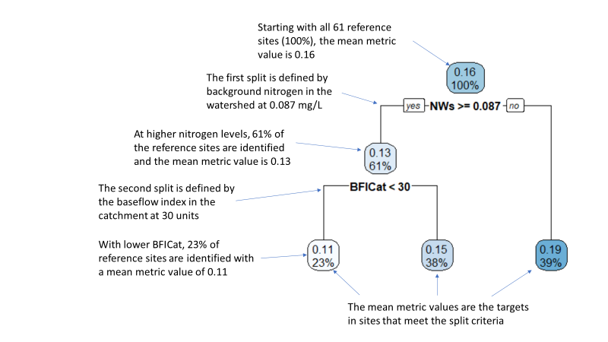

Figure 2. Example of CART results for the pt_BC_12 metric (percent sensitive taxa).

## 3.4 Metric Responses

The ability of each metric to distinguish between reference and stressed sites within a site class was measured as discrimination efficiency (DE) (Flotemersch et al. 2006, Maxted et al. 2000). The distinction between reference and stressed site values is illustrated with box plots that show the median, upper and lower quartiles, minimum, maximum, and outliers (Barbour et al. 1999). The DE is a quantification of the visually apparent distinctions. DE was calculated as the percentage of metric scores in stressed sites that were worse than the worst quartile of those in the reference sites. For metrics with a pattern of decreasing value with increasing environmental stress, DE is the percentage of stressed values below the 25th percentile of reference site values. For metrics that increase with increasing stress, DE is the percentage of stressed sites that have values higher than the 75th percentile of reference values. DE can be visualized on box plots of reference and stressed metric or index values with the inter-quartile range plotted as the box (Figure 3). Higher DE denotes more frequent correct association of metric values with site conditions. DE values ≤25% show no discriminatory ability in one direction. Metrics with DE values ≥ 50% were generally considered for inclusion in the index. However, metric selection was usually dependent on relative DE values within a metric category.

The *Z*-score was a second measure of metric sensitivity to stress. It was calculated as the difference between mean reference and stressed metric or index values divided by the standard deviation of reference values. The *Z-*score is similar to Cohen’s D (Cohen 1992) and gives a combined measure of index sensitivity and precision. There is no absolute *Z*-score value that indicates adequate metric performance, but among metrics or indices, higher *Z*-scores suggest better separation of reference and stressed values. Cohen proposed that *Z* values ≥ 0.80 indicated a “large” effect.

The DE and *Z*-scores summarize the difference in distributions at critical potential threshold levels and incorporate the precision of the reference distribution. They were used in favor of a t-test or signal to noise (S:N) ratio. The DE is an estimate of the percentage of correct impaired assessments and can be interpreted for management applications. While the *t*-test has been used elsewhere (Stoddard et al. 2008), we are not testing a hypothesis about the difference between reference and stressed sites. The *Z*-score and S:N ratio are similar measures of responsiveness as a function of variability.



Figure 3. Box and whisker plot illustrating the percent sensitive valves metric distributions among disturbance categories in the low nitrogen site class. The metric decreases with increasing stress and has a DE slightly less than 75% (estimating from the lower quartile of reference values compared to the distribution of stressed values).

Another component of metric performance is precision of repeated measures. Precision was analyzed as the metric coefficient of variation (CV) of sample sets that were collected at the same site on the same day. This characterizes the metric precision attributable to sampling protocol. A low CV (~ < 30) would indicate a precise metric. Metrics with CVs near and greater than 100 are imprecise and might be avoided when a precise assessment is needed.

From an ANOVA using a replicate set identifier as the grouping variable and metrics as dependent variables, the Root Mean Squared Error (RMSE) was derived as an estimate of the standard deviation of each metric or index. The RMSE was standardized to the replicate sample mean to give the coefficient of variability (CV), which is comparable among metrics. Low CVs (e.g., <30%) would indicate high precision for a metric and if included in an index might contribute to a precise index. Conversely, high CVs (e.g., >75%) could contribute to more variability in an index. The index 90% confidence interval was calculated for each site class as 1.645 * RMSE. Metric precision statistics were calculated for all replicate samples in the data set (not separately by site class). Index precision was calculated using the same methods, but within site classes.

## 3.4 Index Composition

***Metric Scoring***

Metric values vary in scale depending on the units in the measurement and the ranges in the data sets. To give each metric equal weight in the index, metric values were converted to metric scores on a 100-point scale, using the effective range of each metric. The 5th and 95 percentile metric values from all sites were used as the effective ranges of metric variation in the Indiana samples. This recognized the possible range of metric values throughout the state while discounting values that were unusually extreme and possibly outliers (Blocksom 2003). For metrics that decreased with increasing stress, a metric score was calculated as follows:

$$\text{Decreaser} metric score=100* \frac{Metric value – 5th percentile}{95th percentile-5th percentile}$$

For metrics that increase with increasing stress, the calculation was:

$$Increaser metric score= 100* \frac{95th percentile-metric value}{95th percentile-5th percentile}$$

***Metric Selection***

Metrics were selected as candidates for inclusion in the index based on several factors, including the following.

* Sensitivity
  + How well does the metric distinguish between reference and stressed sites?
  + What is the relationship between the metric and the disturbance variables?
    - Direction of response
    - Strength/significance
    - Consistency of response among site classes
* Redundancy
* Representation across metric categories (richness, composition, tolerance to stressors, functional characteristics, etc.)
* Precision

Metric responses that were consistently effective across site classes were preferred to those that were responsive in only one class. The confirmation of response patterns is an important indication of robust response mechanisms, especially when sample sizes are small. The consistent response guards against overfitting the model that might occur when selecting metrics that are responsive only in one site class.

***Index Calculations***

Index compositions were formulated from the best performing metrics in each metric category. The metrics were combined by scoring each on the 0 to 100 scale and then averaging the scores. Each index alternative was then evaluated for discrimination efficiency and other measures of representativeness and sensitivity. Index formulations were created and evaluated in two ways: manual metric substitutions and automatic all-subsets modeling. Initial combinations using manual metric substitutions were used for exploratory analysis. Metrics with high sensitivity in multiple metric categories were scored, combined into an index, and evaluated for sensitivity using DE and Z-scores.

The all-subsets analysis allowed consideration of diverse index compositions that are too numerous to be computed by hand. Twenty candidate metrics were selected for inclusion in index trials based on DE, *Z*-score, and professional opinion of the working group. An “all subsets” routine in R software (R Core Team 2020) was used to combine up to 8 metrics in multiple index trials. Each index alternative was evaluated for performance using DE, *Z*-score, number of metric categories, and redundancy of component metrics. Those models including two or more correlated metrics (Spearman |r| ≥ 0.80) were excluded from consideration. As many metric categories as practical were represented in the index alternatives so that signals of various stressor-response relationships would be integrated into the index. While several metrics should be included to represent biological integrity, redundant metrics can bias an index to show responses specific to certain stressors or taxonomic responses.

***Index Selection***

The multiple possible indices were evaluated by applying a series of criteria for retaining or eliminating indices based on criteria related to sensitivity, redundancy, representation of multiple metric categories, adequate ranges of values, and intelligible response mechanisms. After reducing the possibilities to less than 20 indices, the team of IDEM biologists reviewed and selected the index combination that suited programmatic needs.

## 3.5 Index Validation

A portion of the data were set aside before testing metric responses and index composition, so that the index could be tested with an independent data set. These were randomly selected with the intention of using sufficient sample sizes to represent reference and stressed conditions in all site classes in both calibration and validation analyses. For calibration, at least 10 samples were required so that a reliable reference condition could be characterized and so that stable stressed performance statistics could be calculated. For validation, a minimum of 5 sites were targeted to estimate index performance in sites that were not used in calibration.

The validation process included comparison of the reference and stressed validation index values to the 25th percentile of calibration reference index values. In a perfect validation, 75% of validation reference sites would be greater than the calibration reference 25th percentile and the percentage of stressed sites below that threshold would be as much or more than the DE in each site class. This is a comparison of calibration and validation Type I and Type II errors. Validation error might increase compared to calibration, but it is expected to be within 10% of the calibration error. Greater validation error would indicate the index was too specific to the calibration data, or overfit.

Validation can also compare index values to stressor gradients that were not used in defining the stressor gradient. If the stressors are independent and the index is responsive, then the stressor will likely be detected using the biological index.

## 3.6 Condition Thresholds

Biological indices are intended to describe biological conditions relative to human disturbances. When an index is accurate and precise, it can be used to indicate biological conditions that warrant special protection, are adequate for maintaining aquatic life uses, or are impaired and in need of pollution mitigation. Impairment thresholds are not defined in this report. Rather, approaches and analyses are presented and could be used to justify the selection of thresholds through policy discussions within IDEM.

Once site classes were established and indices were calibrated, some condition thresholds were associated with the 100-point index for assessment of biological condition and possibly for establishing numeric biological criteria. Multiple analyses were used to identify possible thresholds associating ranges of index values with biological condition categories. These included reference distribution statistics, balanced error types, and proportional odds logistic regression.

***Reference Distribution Statistics***

The reference condition (RC) approach is the most commonly used method to derive biological thresholds (e.g., Yoder and Rankin 1995, DeShon 1995, Barbour et al. 1996, Roth et al. 1997). With the RC approach, IBI scores are calculated from a reference site dataset, and then a percentile of the IBI scores, such as the 25th or 10th, is chosen to represent the RC. If a reference condition is not defined, the 75th percentile of all site values could be considered (U.S. EPA 2000).

The Indiana diatom IBI was developed using reference condition concepts to identify sites with relative degrees of disturbance due to human activities. The reference and highly stressed conditions for sampled sites were defined using quantitative criteria of stressors and stressor sources. The absolute degree of disturbance is undefined, though there are relatively fewer stressors in the reference sites compared to intermediate and high-stress sites.

Distribution statistics in reference sites and all sites can inform possible thresholds, allowing assessment of sites that are similar to reference. These reference sites have few stressors and a biological condition representing a somewhat natural standard. Any index value above the minimum of reference index values might be a reference site. However, it is likely that the minimum value is not representative of acceptable reference conditions because a) the reference sites were defined with relative, not absolute, stressor criteria, b) there is variability in biological conditions, and c) there might be undetected stressors due to limited data availability. Rather, the minimum reference index value probably should not be recognized as an acceptable natural standard. In contrast, a threshold set at the median of index values would discount half of the reference sites, which would suggest that the reference sites were poorly defined, and the reference condition has substantial errors.

Thresholds based on a lower percentile of reference IBI scores describe points on the index scale above which conditions represent predominantly natural community types and below which biological conditions are departing from the core natural standard and might be impacted, erroneously designated reference sites, or simple errors due to biological and site variability. The 10th - 25th percentiles of reference index values are common thresholds used in bioassessments. One of these percentiles could be selected as a threshold for assessing low gradient biological conditions using the IBI.

***Balanced Errors***

One strategy for selecting a threshold is to balance errors in assessing reference and highly stressed sites: there should be as many reference sites identified as impacted as there are highly stressed sites identified as unimpacted. This is based on the premise that each data set and condition was identified with equal degrees of certainty and therefore error should be the same. Type I and Type II errors are associated with reference sites erroneously identified as impacted and highly stressed sites identified as unimpacted, respectively.

***Secondary Thresholds***

Secondary thresholds can be identified within the generally unimpacted and generally impacted index ranges. This would allow for refined emphasis in biological condition when prioritizing or justifying management decisions. Within the generally unimpacted index range, refined conditions could be described as Exceptional or Satisfactory based on a secondary threshold derived from a simple bisection of the unimpacted index range, half-way between the general threshold and the maximum of the index scale. Similarly, the impacted range of the index scale could be bisected to describe a threshold between Moderately Degraded and Severely Degraded.

A more complex determination of secondary thresholds can be explored using proportional odds logistic regression (polr). This technique estimates the probabilities of membership in the reference, moderately stressed, and highly stressed groups based on index values within those categories. The points at which there is an equal probability between groups can describe a potential threshold that would evenly divide the Exceptional and Satisfactory index values and also the Moderately Degraded and Severely Degraded index values. These thresholds recognize the observed range of index values within disturbance groups, as opposed to the simple bisection, which uses the entire range of index values, regardless of the observed range. Recognition of the observed range of values is a more empirical method that is recommended.

# Results

## 4.1 Site Disturbance

Of the 409 sites, 61 were designated as reference sites, in the sub-categories of BestRef, Ref, and SubRef (Table 3). Eighty-two (82) sites were designated as stressed (Strs and HighStrs) and 266 as intermediate stress sites. Relatively undisturbed and stressed sites were found throughout Indiana, though some regions (such as the Central Corn Belt Plains in the northwest) were not represented by reference sites. A high percentage of sites in Interior Plateau ecoregion (#71) were relatively undisturbed and few sites in this ecoregion were stressed (Figure 4). The greatest number of sites were in the Eastern Corn Belt Plains ecoregion (#55), which had the greatest number of reference and stressed sites compared to other ecoregions. Reference sites also occurred in the Southern Michigan / Northern Indiana Drift Plains (#56) and the Interior River Lowlands (#72). Figure 5 shows the range of stressor values represented across the disturbance gradient, as measured by percent urban land use, percent agricultural land use, total phosphorus concentration, qualitative habitat evaluation index (QHEI), chloride concentration, and total copper concentration. Appendix C contains additional box plots with disturbance variables as well as natural variables (such as drainage area, slope, and elevation). Appendix D contains the site list with final disturbance category assignments.

Though the criteria for designating sites in disturbance categories included agricultural land use, it was possible to attain reference status if intensive land use was the only one or one of few stressors. Several of the criteria were related to urban activities, such as urban land use coverage, percent imperviousness, population density, and road crossings. Habitat quality was not an explicit criterion and the QHEI did not vary appreciably among disturbance categories. Several chemical pollutant concentrations, including nutrients, metals and salts, increased as disturbance categories represented increasing stress.

Table 3. Tabulation of diatom sampling sites by disturbance category and ecoregion in Indiana.

|  |  |  |  |  |  |  |  |  |
| --- | --- | --- | --- | --- | --- | --- | --- | --- |
|  | Ecoregion: | 54 | 55 | 56 | 57 | 71 | 72 | Totals |
| Reference | BestRef |  |  |  |  | 1 |  | 1 |
| Ref |  | 6 | 4 |  | 9 | 1 | 20 |
| SubRef |  | 17 | 5 |  | 10 | 8 | 40 |
| Intermediate | Intermediate | 30 | 110 | 25 | 1 | 48 | 52 | 266 |
| Stressed | Strs | 9 | 27 | 8 | 2 | 4 | 10 | 60 |
| HighStrs | 4 | 16 | 2 |  |  |  | 22 |
| Totals | Totals | 43 | 176 | 44 | 3 | 72 | 71 | 409 |

Ecoregions include the Central Corn Belt Plains (54), the Eastern Corn Belt Plains (55), the Southern Michigan / Northern Indiana Drift Plains (56), the Huron/Erie Lake Plains (57), the Interior Plateau (71), and the Interior River Lowlands (72).

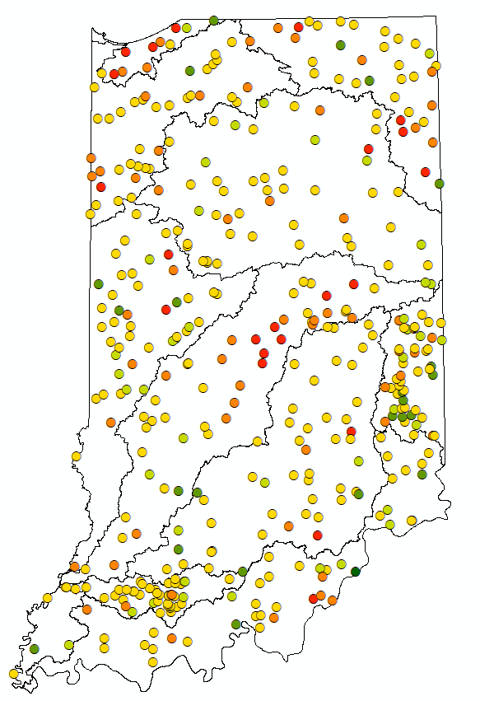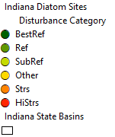

EFW

LW

OR

UW

WFW

OR

MR

GL

KI

EFW East Fork White

GL Great Lakes

KI Kankakee/Iriquois

LW Lower Wabash

MR Miami River

OR Ohio River

P Patoka

UW Upper Wabash

WFW West Fork White

P

Figure 4. Diatom sampling sites in river basins of Indiana color-coded by disturbance category.





Figure 5. Distributions of selected stressors among disturbance categories, showing percent urban land use, percent agricultural land use, total phosphorus concentration, qualitative habitat evaluation index (QHEI), chloride concentration, and total copper concentration.

The disturbance categories were established based on the process outlined in Section 3.2. Though it was not intended, there were some natural variables showing patterns across the disturbance gradient, such as latitude, drainage area, the wetness index (related to topography), and precipitation (Figure 6). Other variables did not vary with disturbance category, such as elevation, base flow index (BFI), and K-factor (related to soil erodibility) (Appendix C).



Figure 6. Distributions of selected natural characteristics among disturbance categories, showing latitude, drainage area, the wetness index (related to topography), and precipitation.

## 4.2 Site Classification

***Natural Background Conditions***

Biological samples from 65 reference sites (BestRef, Ref, and SubRef) were used in the classification analysis, with only one sample per site included. The reference sites were fairly well distributed across the state, though there were spatial gaps in central and northwest Indiana (Figure 7). Reference sites were found in all ecoregions except the Central Corn Belt Plains (54) and the Huron/Erie Lake Plains (57). River basins, ecoregions, and benthic macroinvertebrate classification regions were tested as potential regional classification schemes for diatoms (Figures 7 and 8). Several other environmental variables were tested for correlations with ordination axes, including the base flow index (BFI) and site elevation (Figure 9).

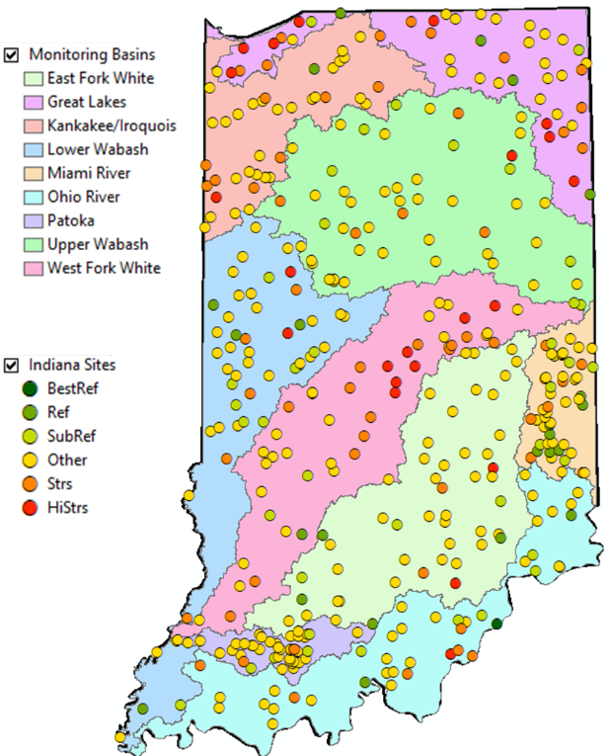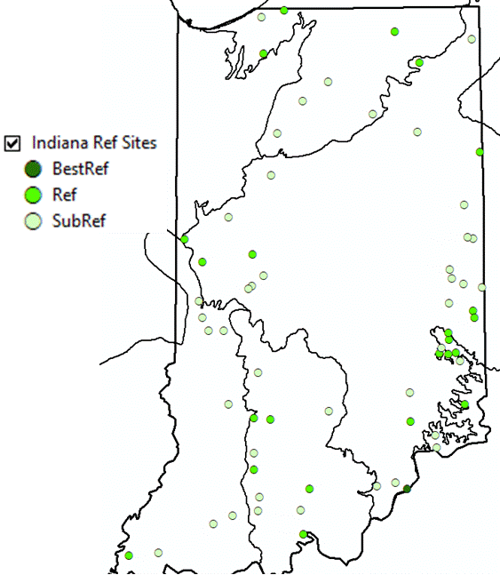

Figure 7. Reference sites in Indiana ecoregions (left, see ecoregion map in Figure 8) and all sites by disturbance category in river basins (right)

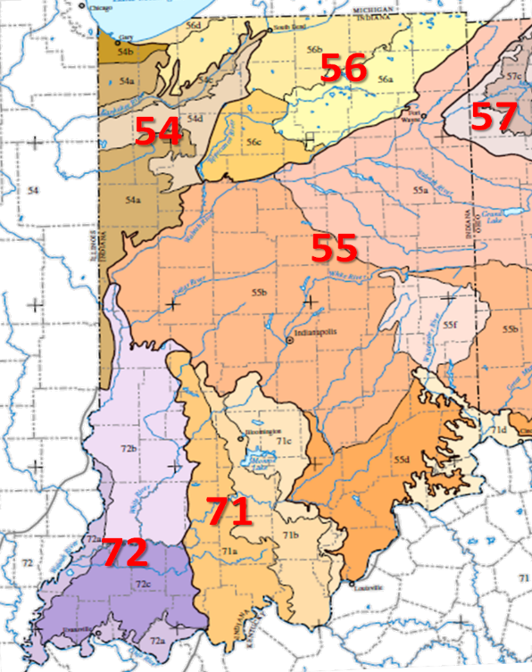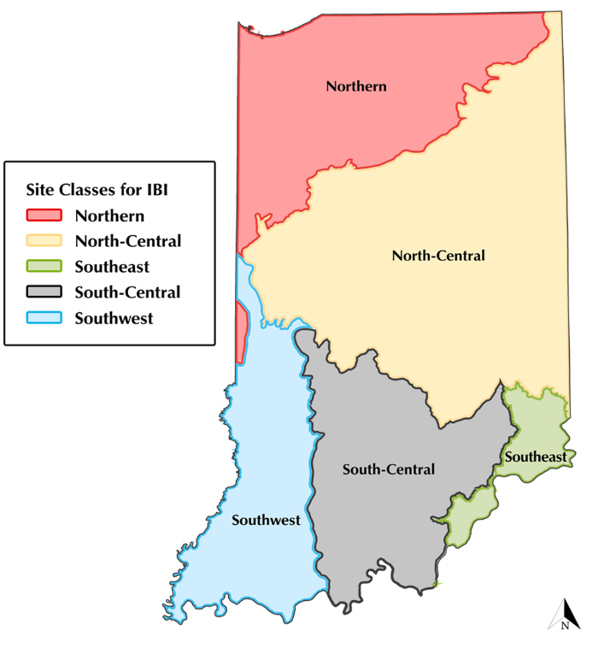

Figure 8. Macroinvertebrate assessment regions in Indiana (left) and Indiana ecoregions (right). Ecoregions include the Central Corn Belt Plains (54), the Eastern Corn Belt Plains (55), the So. Michigan / No. Indiana Drift Plains (56), the Huron/Erie Lake Plains (57), the Interior Plateau (71), and the Interior River Lowlands (72).

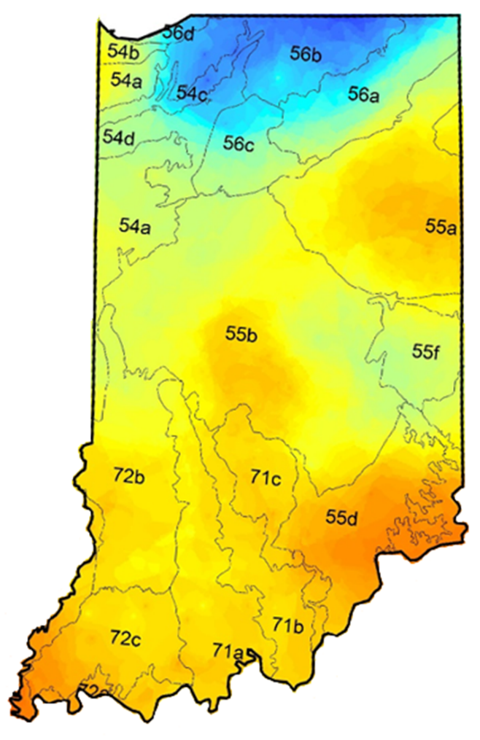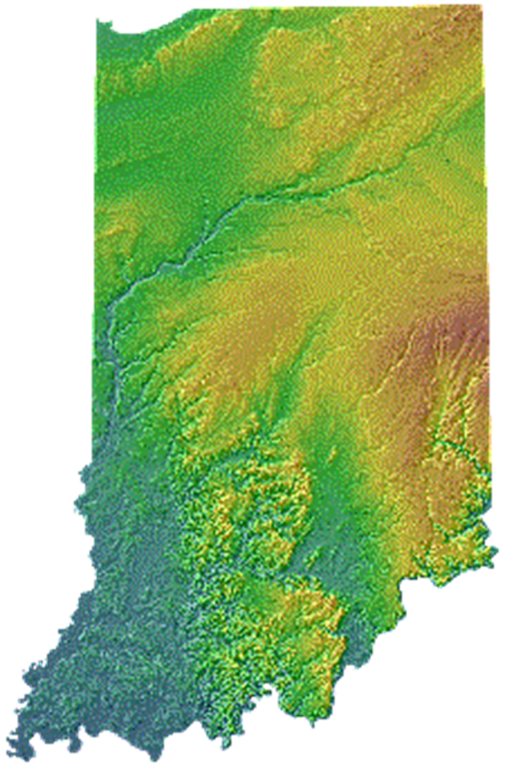

Figure 9. Base flow index (BFI) in Indiana ecoregions (left) and topographic elevation (right). For the BFI, blue tones indicate greater groundwater influence on stream flow and orange indicates less influence of groundwater. For elevation, brown tones are higher and blue tones are lower.

***Preliminary Classification Analysis***

One hundred eighty-four (184) taxa, 29 metrics, and 59 environmental variables were included in the exploratory site classification analyses using NMS ordination of taxa, PCA ordination of metrics, and clustering of taxa with CART analysis. The analyses were informative, but ultimately inconclusive because they did not result in recognizable and distinct categories of site types. The ordination diagrams with taxa similarities, metric similarities, and clusters resulted in plots of overlapping sites when plotted by multiple categorical variables, such as ecoregion and precipitation (Figure 10). Though the categorical site classes had precedent in Indiana biological assessment (Jessup and Stamp 2017), they were not apparent as diatom site classes (Appendix E).

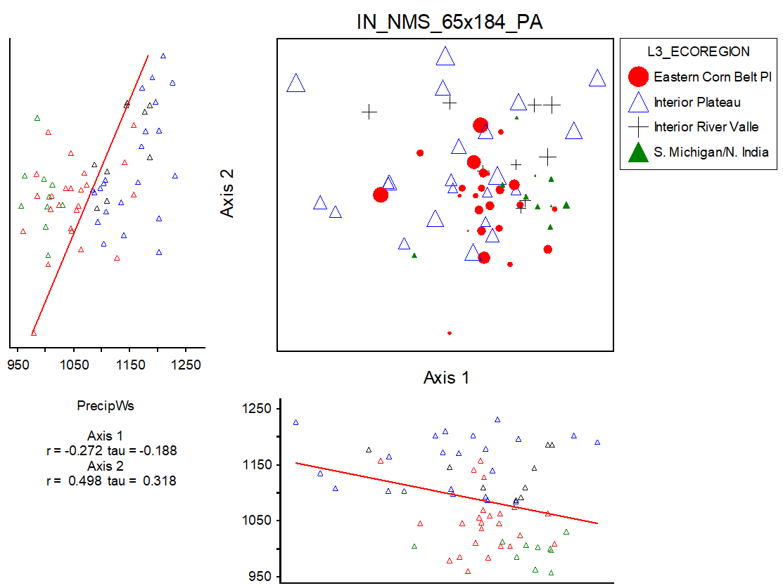

Figure 10. Non-metric multidimensional scaling (NMS) diagram showing reference sites arranged by taxonomic similarity and marked by ecoregion and precipitation (size of the marker).

***Correlation Analysis***

The lack of a clear site classification in the preliminary analyses lead to a correlation analysis with metrics and environmental variables so that individual metrics might be adjusted as needed. The correlation analysis was used to select the variables and metrics used for individual metric adjustments. Acidity (pH and alkalinity) was suspected of having some effects on metrics and of having primarily natural origins. The range of pH in reference and non-reference sites was similar, supporting the idea that pH was not a stressor variable. Pearson correlation coefficients had magnitudes > 0.25 for pH in 27 of 270 metrics tested. The highest correlations were with oligotrophic taxa richness; high pH was associated with few oligotrophic taxa in reference sites and in all sites. High pH was also associated with fewer eutrophic individuals. The correlation coefficients and mixed signals suggest that pH has minor effects on some metrics.

Other correlations with water quality were apparent but were possibly related to stressor effects. For example, richness metrics were correlated with water temperature. Chloride was correlated with reference metrics, but is likely a stressor indicator and not an appropriate classification variable. Turbidity was correlated with metrics, also associated with chloride and nutrients, and not an appropriate classification variable. The variables that had high correlation coefficients with several metrics included slope, wet index, BFI, precipitation, temperature, and predicted lithologic chemistry (Ca, Na, Fe, and N) (Table 4). There were also some weak signals with elevation and catchment size.

Table 4. Correlation coefficients for selected metrics and environmental variables with relatively high correlation coefficients (Spearman |rho| > 0.30). Metric and variable descriptions are in Attachment 1 and Appendix F, respectively.

|  |  |  |  |  |  |  |  |  |  |
| --- | --- | --- | --- | --- | --- | --- | --- | --- | --- |
| Variable | SLOPE | BFI Cat | Wet Index Cat | Precip Ws | Tmean Ws | Na2O Cat | CaO Ws | Fe2O3 Ws | N Ws |
| MMI_NRSA | 0.36 | -0.44 | -0.56 | 0.53 | 0.51 | -0.42 | 0.51 | -0.48 | -0.46 |
| nt_HIGH_N |  | 0.33 | 0.45 | -0.49 | -0.47 |  |  |  |  |
| pi_Diatas_TN_2 |  |  |  |  |  | -0.30 | 0.44 |  | -0.39 |
| pi_Diatas_TP_2 |  |  |  |  |  | -0.32 | 0.41 | -0.30 | -0.38 |
| pi_HIGH_N |  |  |  | -0.46 | -0.35 |  |  |  |  |
| pt_N_FIXER | 0.40 |  |  |  |  |  |  |  |  |
| pt_NON_N_FIXER | -0.40 |  |  |  |  |  |  |  |  |
| pi_Diat_CA_1 |  |  |  | -0.43 | -0.39 |  |  |  |  |
| nt_O_3 |  | 0.33 | 0.34 |  |  |  |  |  |  |
| pi_O_2 | 0.47 |  |  |  |  |  |  |  |  |
| pt_O_2 | 0.44 |  |  |  |  |  |  |  |  |
| nt_TROPHIC_3 |  | -0.31 | -0.39 | 0.49 | 0.43 |  |  |  |  |
| pi_TROPHIC_4 |  | 0.45 | 0.39 |  |  | 0.43 | -0.33 | 0.35 |  |
| pt_TROPHIC_3 |  | -0.40 | -0.52 | 0.57 | 0.50 | -0.37 | 0.41 | -0.44 | -0.39 |
| pt_SAP_2 | 0.53 |  |  |  |  |  |  |  |  |
| pt_BC_3 | 0.40 |  |  |  |  |  |  |  |  |
| pi_BC_4 |  | 0.34 | 0.37 | -0.53 | -0.50 |  |  |  |  |
| nt_PT_4 |  | 0.40 |  | -0.56 | -0.61 |  |  |  |  |
| pt_PT_4 | 0.41 |  |  |  |  |  |  |  |  |
| pt_Bahls_3 | 0.45 |  |  |  |  |  |  |  |  |
| pt_SALINITY_2 | 0.46 |  |  |  |  |  |  |  |  |
| nt_BIG |  | 0.55 | 0.31 | -0.5 | -0.54 | 0.39 | -0.30 | 0.47 | 0.37 |
| pi_BIG |  | 0.44 |  |  |  |  |  |  |  |
| pi_SMALL |  |  |  |  |  |  | -0.39 | 0.34 | 0.37 |
| pt_BIG |  | 0.51 |  | -0.43 | -0.48 | 0.43 |  | 0.49 | 0.39 |
| pt_VERY_SMALL |  |  |  |  |  | -0.31 | 0.47 | -0.33 | -0.35 |
| WA_Size_USGS |  | 0.40 |  |  |  |  |  |  |  |
| wa_Moisture |  | -0.47 | -0.47 | 0.32 | 0.44 | -0.50 | 0.39 | -0.45 | -0.39 |
| pi_NAVICULA |  | 0.41 | 0.48 | -0.47 | -0.5 | 0.31 | -0.38 | 0.41 | 0.35 |

***Metric Adjustment***

Variables were selected for metric adjustment based on the correlation analysis and judgement on their appropriateness for classification (e.g., not subject to human disturbance, reliable measurements, etc.). Variables were selected if they were consistently and strongly correlated to metrics at a Spearman |*rho*| > 0.40 in reference sites. Variables were also selected if they were not the strongest correlations, but that were common over several metrics. For example, BFICat. BFICat was selected for metric adjustments over BFIWs because they consistently had similar correlation coefficients with environmental variables, but BFICat was correlated at |*rho*| > 0.40 for 10 metrics, while BFIWs was correlated to 8 metrics. The selected variables for adjustment included BFICat (base flow), TminCat (temperature), PrecipCat (precipitation), WetIndexCat (topography), CaOWs (background calcium oxide), NWs (background nitrogen), and SLOPE (stream gradient). Metrics from the preliminary index were adjusted by one or two variables identified in CART analysis (Table 5). The purpose of the metric adjustment was to refine the discrimination performance of the metrics to recognize natural background expectations. However, after adjustment, the preliminary index had a lower DE than the unadjusted version (65.6% vs. 75.4 %), and the adjustments were not applied as planned.

Table 5. Metrics in the preliminary index and the classification variables used for adjustments.

|  |  |
| --- | --- |
| Index Metric | Adjustment Variables |
| pt_BC_12 | NWs and BFICat |
| nt_LOW_P | PrecipCat |
| pt_O_345 | NWs |
| pt_HIGHLY_MOTILE | WetIndexCat and BFICat |
| pt_SESTONIC_HABIT | SLOPE and TminCat |
| pt_RefIndicators | NWs and PrecipCat |

***Final Classification Analysis***

The final classification analysis included CART analysis of the preliminary index. At first, background nitrogen (NWs[3]) and precipitation (PrecipCat) were the first and second splits of the reference index values. Results showed that precipitation explained relatively little variability after accounting for background nitrogen. Ultimately, the best classification scheme used a background nitrogen threshold of 0.089 % to describe high nitrogen (HiN) and low nitrogen (LoN) conditions (Figure 11). The breakpoint is supported by similar breakpoints derived from CART analysis of individual metrics.

Within the two site classes, metric adjustments were again evaluated. For most metrics, CART analysis did not identify different expectations. The nitrogen classes accounted for most variability. This was evident in values of the environmental variables, which were distinguishable in the two nitrogen classes (Figure 12). Sites in both site classes were distributed throughout the state, though most low nitrogen sites were in the southern half of the state (Figure 13).

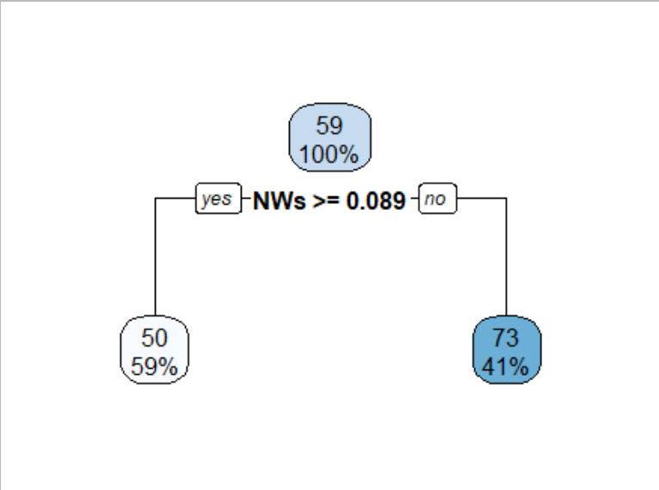

Figure 11. CART diagram showing that reference preliminary index values were split into high nitrogen and low nitrogen categories based on a geological nitrogen (NWs) threshold of 0.089 %.

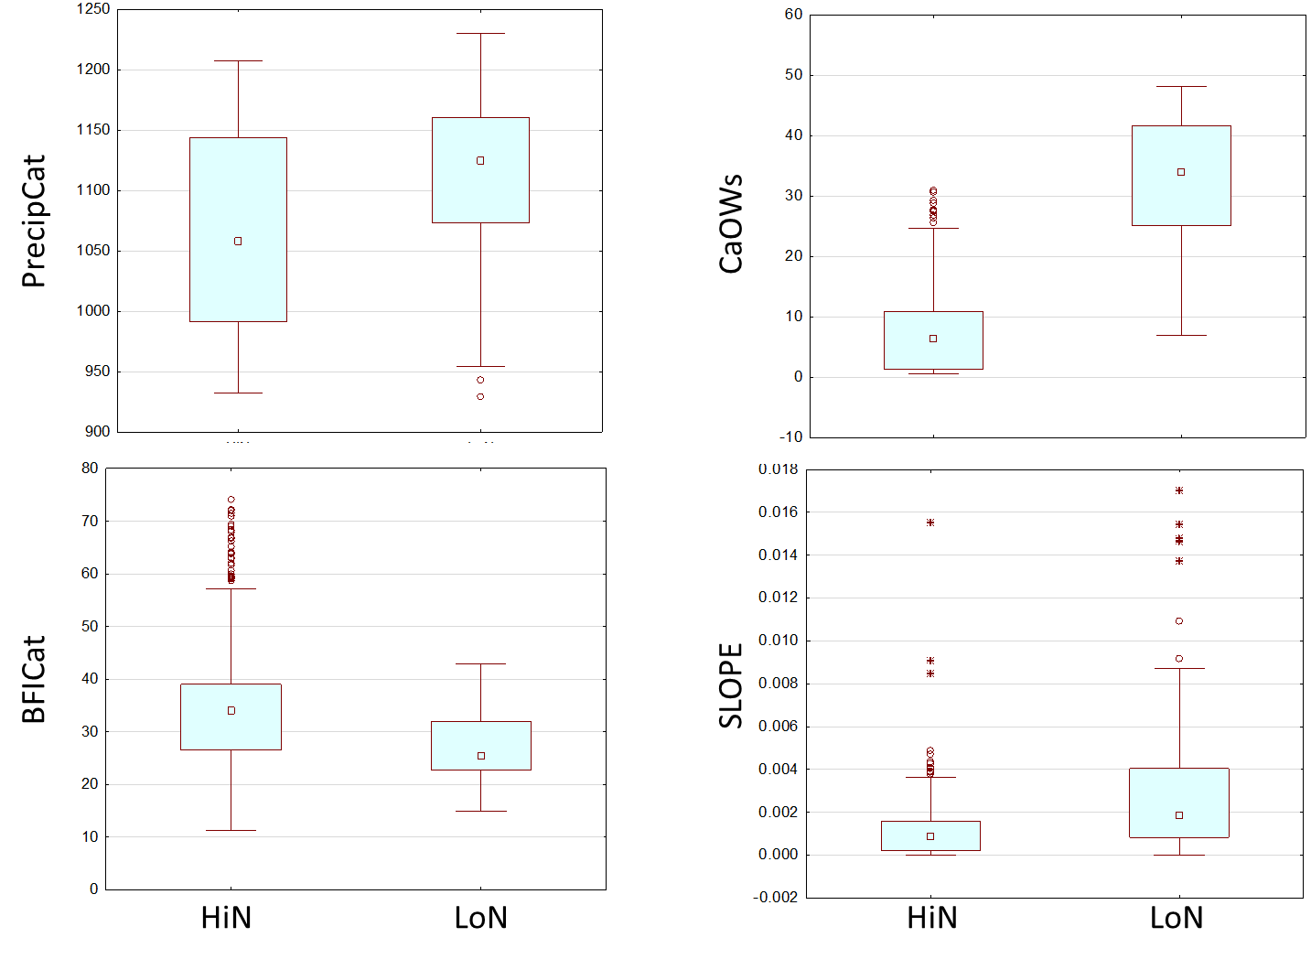

Figure 12. Classification variable distributions in high nitrogen (HiN) and low nitrogen (LoN) site classes.

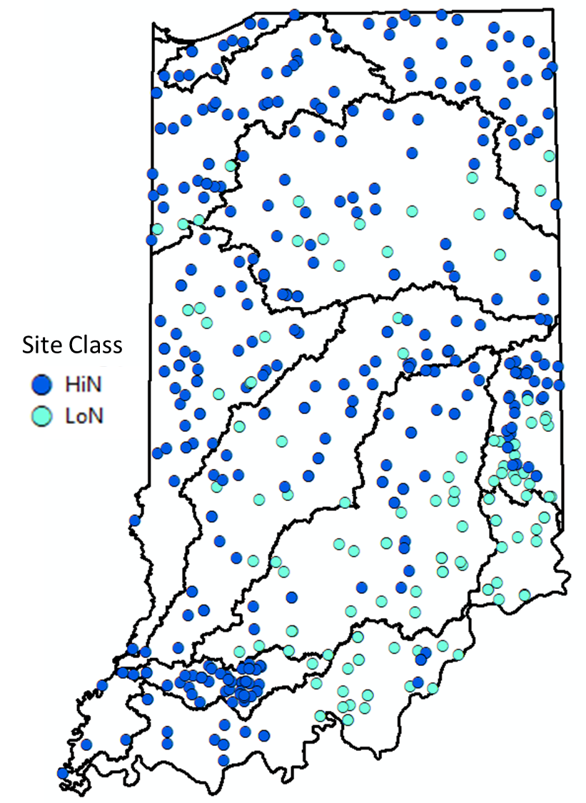

Figure 13. Diatom sampling site locations marked by site class; high nitrogen (HiN) or low nitrogen (LoN).

## 4.3 Traits and Tolerance Analysis

To help inform tolerance value assignments, we ran taxa tolerance analyses on the Indiana diatom dataset to explore the distribution of taxa across four generalized disturbance measures: the Index of Watershed Integrity (IWI, Thornbrugh et al. 2018, Johnson et al. 2018), Qualitative Habitat Evaluation Index (QHEI), stream conductivity (Cond) and watershed imperviousness (Imperv_W). Taxa that occurred at fewer than 10 sites were excluded from the analysis because low numbers of occurrences gave unreliable results. Tolerance analyses allow for visualization of the shape of the taxon-stressor relationship across a continuous numerical scale and can be used to identify optima (the point at which the taxon has the highest probability of occurrence) as well as tolerance limits (the range of conditions in which the taxon can persist) (Yuan 2006).

Taxa traits and tolerance values were used to calculate 308 metrics. The traits and tolerance values are in Attachment 2. Tolerance value graphic output for diatom genera are in Appendix G. Metric descriptions are in Attachment 1.

## 4.4 Metric Responses

The metrics were screened for responsiveness so that the most sensitive metrics could be included in the index. While 308 metrics were calculated, 88 metrics in the HiN class and 181 in the LoN class had responses that were sensitive (DE > 40) and had a non-contradicting response trend among the classes (Appendix H). Consistently responsive metrics were identified in most of the metric categories. Of the 15 metric categories in the metric list, all were represented in the consistently responsive metrics in the LoN class and all but two were represented in the HiN class: total taxa richness and affinity for moisture.

For the all-subsets modeling, the metrics were limited to about 20 metrics, which is a practical limit for running the iterative code. The selection criteria included metric performance (DE), representation within a metric category, independence from other selected metrics (non-redundant), and adequate range of values. The resulting selections are as in Tables 6 and 7 for the LoN and HiN site classes, respectively.

In the LoN site class, no metrics were selected from the following categories because the metric DEs were relatively low: acidity, habit, moisture, motility, richness, saprobity, and size. In the HiN site class, no metrics were selected from the following categories: acidity, moisture, motility, richness, saprobity, size, and trophic.

Table 6. Candidate metrics for the LoN All-subsets model analysis

|  |  |  |  |
| --- | --- | --- | --- |
| Metric | Metric Category | DE (trend) | Z-score |
| nt_BC_12 | Biological Condition | 90.9 (DEC) | 1.9 |
| pt_BC_12 | 81.8 (DEC) | 1.4 |
| pt_O_345 | Oxygen | 72.7 (INC) | -1.2 |
| pt_RefIndicators | Indicators | 100 (DEC) | 1.4 |
| nt_LOW_P | Nutrients | 81.8 (DEC) | 1.7 |
| nt_LOW_N | 72.7 (DEC) | 1.3 |
| pt_LOW_P | 72.7 (DEC) | 0.9 |
| pt_HIGH_N | 90.9 (INC) | -2.0 |
| pi_LOW_P | 72.7 (DEC) | 0.7 |
| pi_LOW_N | 72.7 (DEC) | 0.7 |
| pt_PT_12 | Pollution Tolerance | 63.6 (INC) | -0.5 |
| pt_Bahls_1 | 54.5 (INC) | -0.6 |
| wa_Poll_Tol | 72.7 (DEC) | 0.7 |
| pt_Sens_810 | 81.8 (DEC) | 1.7 |
| nt_SALINITY_12 | Salts | 54.5 (DEC) | 0.7 |
| pt_SALINITY_34 | 90.9 (INC) | -2.0 |
| nt_Achnan_Navic | Taxa Group | 81.8 (DEC) | 1.1 |
| pt_Achnan_Navic | 81.8 (DEC) | 1.5 |
| pi_Achnan_Navic | 72.7 (DEC) | 0.9 |
| pt_TROPHIC_456 | Trophic | 63.6 (INC) | -0.5 |

Table 7. Candidate metrics for the HiN all-subsets model analysis

|  |  |  |  |
| --- | --- | --- | --- |
| Metric | Metric Category | DE (trend) | Z-score |
| pt_BC_12 | BC | 50 (DEC) | 0.6 |
| pt_BC_12_adj | 54.3 (DEC) | 0.6 |
| pt_BC_45 | 50 (INC) | -0.1 |
| pt_O_345_adj | DO | 45.7 (INC) | -0.3 |
| pt_SESTONIC_HABIT | Habit | 54.3 (INC) | -0.6 |
| pt_RefIndicators_adj | Indicators | 52.2 (DEC) | 0.5 |
| pi_RefIndicators | 50 (DEC) | 0.1 |
| nt_LOW_P | Nutrients | 52.2 (DEC) | 0.3 |
| nt_LOW_N | 43.5 (DEC) | 0.3 |
| pt_LOW_P | 43.5 (DEC) | 0.3 |
| pi_LOW_P | 43.5 (DEC) | 0.0 |
| pi_HIGH_P | 50 (INC) | -0.6 |
| pt_PT_12 | PollToler | 50 (INC) | -0.2 |
| pt_Bahls_1 | 52.2 (INC) | -0.6 |
| pi_PT_45 | 41.3 (DEC) | 0.0 |
| wa_Poll_Tol | 41.3 (DEC) | 0.0 |
| pi_Tol_13 | 52.2 (INC) | -1.1 |
| pi_SALINITY_4 | Salts | 47.8 (INC) | -1.3 |
| pi_Diat_CL_1_ASSR | 52.2 (INC) | -1.2 |
| pt_Achnan_Navic | TaxaGroup | 45.7 (DEC) | 0.5 |

In the HiN site class, three of the selected metrics for the all-subsets modeling were adjusted using CART analysis to account for natural variability. These included pt_BC_12_adj, pt_O_345_adj, and pt_RefIndicators_adj (Table 8). Also in the HiN site class, the pi_Diat_CL_1_ASSR metric used the *arcsine (square root)* transformation to expand the range of low percentage values. None of the selected metrics were adjusted or transformed in the LoN site class.

Table 8. Adjustment formulae for candidate HiN index metrics.

|  |  |  |
| --- | --- | --- |
| Metric | Adjustment Variable and Threshold | Adjustment Formula |
| pt_BC_12_adj | BFIcat at 30 units | pt_BC_12_adj =  If BFIcat < 30,  then pt_BC_12 – 0.105,  else pt_BC_12 – 0.151 |
| pt_O_345_adj | NWs at 0.158 % | pt_O_345_adj =  If NWs < 0.158,  then pt_O_345 – 0.312,  else pt_O_345 – 0.387 |
| pt_RefIndicators_adj | PrecipCat at 1006 mm/yr | pt_RefIndicators_adj =  If PrecipCat < 1006,  then pt_RefIndicators - 6.29,  else pt_RefIndicators - 10.9 |

Metric scoring proceeded using the 5th and 95th percentile of all data (both site classes and all disturbance categories) except when substantial differences were noted in statistics between site classes (Table 9). The reliance on the whole data set assured that the entire range of possible values would be addressed, but when the metric values were limited in one site class, the limited range was used to optimize the metric response within the effective range.

Table 9. Scoring formulae for candidate metrics in the LoN and HiN site classes. In the scoring formulae, replace ‘metric’ with the sample metric value to calculate the metric score.

|  |  |  |  |
| --- | --- | --- | --- |
| Metric | Metric Category | LoN Formula | HiN Formula |
| nt_BC_12 | BC | 100*(metric - 2)/(13 - 2) |  |
| pt_BC_12 | 100*(metric - 0.05)/(0.23 - 0.05) | 100*(metric - 0.05)/(0.23 - 0.05) |
| pt_BC_12_adj |  | 100*(metric + 0.09)/(0.07 + 0.09) |
| pt_BC_45 |  | 100*(0.75-metric)/(0.75-0.43) |
| pt_O_345 | Dissolved Oxygen | 100*(0.47-metric)/(0.47-0.24) |  |
| pt_O_345_adj |  | 100*(0.14-metric)/(0.14+0.12) |
| pt_SESTONIC_HABIT | Habit |  | 100*(0.20-metric)/(0.20) |
| pi_RefIndicators † | Indicators |  | 100*(metric - 0.7)/(27.6 - 0.7) |
| pt_RefIndicators † | 100*(metric - 4.5)/(26.2 - 4.5) |  |
| pt_RefIndicators_adj |  | 100*(metric + 10.9)/(7.5 + 10.9) |
| nt_LOW_N | Nutrients | 100*(metric - 1)/(8 - 1) | 100*(metric - 1)/(8 - 1) |
| nt_LOW_P | 100*(metric - 1)/(7 - 1) | 100*(metric - 1)/(7 - 1) |
| pi_HIGH_P |  | 100*(0.75-metric)/(0.75-0.11) |
| pi_LOW_N † | 100*(metric - 0.01)/(0.70 - 0.01) |  |
| pi_LOW_P † | 100*(metric - 0.01)/(0.70 - 0.01) | 100*(metric)/(0.26) |
| pt_HIGH_N | 100*(0.55-metric)/(0.55-0.33) |  |
| pt_LOW_P | 100*(metric - 0.05)/(0.15 - 0.05) | 100*(metric - 0.05)/(0.15 - 0.05) |
| pi_PT_45 | Pollution Tolerance |  | 100*(metric - 0.03)/(0.59 - 0.03) |
| pi_Tol_13 |  | 100*(49.6-metric)/(49.6-1.6) |
| pt_Bahls_1 | 100*(0.18-metric)/(0.18-0.03) | 100*(0.18-metric)/(0.18-0.03) |
| pt_PT_12 | 100*(0.20 - metric)/(0.20 - 0.07) | 100*(0.20 - metric)/(0.20 - 0.07) |
| pt_Sens_810 | 100*(metric - 0.10)/(0.40 - 0.10) |  |
| wa_Poll_Tol | 100*(metric - 1.9)/(3.9 - 1.9) | 100*(metric - 1.9)/(3.9 - 1.9) |
| nt_SALINITY_12 | Salts | 100*(metric - 17)/(47.2 - 17) |  |
| pi_Diat_CL_1_ASSR |  | 100*(0.20-metric)/(0.20) |
| pi_SALINITY_4 |  | 100*(0.40-metric)/(0.40) |
| pt_SALINITY_34 | 100*(0.25-metric)/(0.25-0.07) |  |
| nt_Achnan_Navic | Taxa Groups | 100*(metric - 4.8)/(18 - 14.8) |  |
| pi_Achnan_Navic | 100*(metric - 0.04)/(0.49 - 0.04) |  |
| pt_Achnan_Navic | 100*(metric - 0.14)/(0.32 - 0.14) | 100*(metric - 0.14)/(0.32 - 0.14) |
| pt_TROPHIC_456 | Trophic Status | 100*(0.66-metric)/(0.66-0.43) |  |

† Metric scoring was based on the 5th and 95th percentiles of all data within the site class (all other metrics used the 5th and 95th percentile across both site classes).

## 4.5 Index Composition

The all-subsets model calculation and screening resulted in thousands of valid index combinations. Initially, the all-subsets analysis resulted in more than 110,000 different index combinations of non-redundant metrics in both the HiN and LoN site classes. To identify the most sensitive, comprehensive, and practical index alternatives, the characteristics of the alternatives were screened for favorable characteristics such as high index DEs and representation of multiple metric categories. Metrics with conceptual redundancy were identified and index alternatives with more than one similar metric were removed from consideration. Index alternatives were also discounted if they used metrics that had relatively low DE in the metric category, if the metric response mechanism was poorly understood, if the range of metric values was limited, or if metric calculation was complex relative to alternative metrics. Application of index removal criteria was done with approval of the IDEM workgroup and a final index was selected and justified.

In the HiN site class, 137,678 index models were systematically reduced to two alternatives using exclusion criteria (Table 10). The final index was selected because it had more metric calculation types, which is assumed to allow a broader diversity of responses and an index that will be more effective at detecting disturbance. In the LoN site class, 113,618 index models were systematically reduced to 37 alternatives using similar exclusion criteria (Table 11). The final index selection for the LoN site class was based on preference for some metrics and exclusion of others using nuanced criteria that were not applied as quantitative or uniform rules (Table 12). Of the 37 alternative that remained after application of the criteria in Table 11, one alternative was selected and approved by IDEM.

The final indices for the HiN and LoN site classes each had five component metrics (Table 13). The HiN index had a DE of 71.7% and a Z-score of 1.1. The LoN index had a DE of 100% and a Z-score of 3.2. The index scores reflected the relative degrees of stress in the sites. The HiN index performs well in both site classes, though it was customized for only the HiN class (Figure 14). The LoN index performs best in the LoN class (Figure 15). In both indices, the sites with intermediate disturbance status showed a span of values that was broader than either the reference or stressed values. The intermediate disturbance sites had median values and interquartile ranges that were intermediate to the reference and stressed statistics.

Table 10. Conditions for exclusion of the HiN index alternatives from consideration as final indices

|  |  |
| --- | --- |
| **Index alternative exclusion criteria** | **Remaining Models** |
| **Initial Number of Models** | 137,678 |
| **Number of metrics < 5:** A limited number of metrics will limit the index sensitivity to few stressors and response mechanisms | 132,316 |
| **Number of metric categories < 4:** A limited number of metric categories will limit the index sensitivity to few stressors and response mechanisms | 129,802 |
| **Number of nutrient metrics > 2:** If the index is overweighted in one metric category, sensitivity will be biased towards the targeted stressor (nutrients) | 113,926 |
| **DE < 60:** A low DE indicates poor sensitivity compared to other models | 21,290 |
| **Conceptually redundant low P metrics (nt_LOW_P, pt_LOW_P and pi_LOW_P):** Though not statistically correlated at |r| > 0.80, multiple low P metrics would bias the index towards sensitivity to phosphorus | 15,456 |
| **Conceptually redundant regionally calibrated tolerance metrics (pi_RefIndicators and pi_Tol_13):** Multiple regionally calibratedtolerance metrics would bias the index and might be overfit to this data set | 10,761 |
| **Conceptually redundant salts metrics (pi_SALINITY_4 and pi_Diat_CL_1_ASSR):** Multiple metrics related to dissolved salts would bias the index towards sensitivity to ion content | 9,118 |
| **Conceptually redundant biological condition (BC) metrics (pt_BC_12, pt_BC_12_adj and pt_BC_45):** Multiple BC metrics would bias the index towards sensitivity to this tolerance characteristic | 6,679 |
| **DE < 69:** A lower DE indicates poor sensitivity compared to other models | 273 |
| **Index alternatives with pi_LOW_P:** This metric was included in the sensitive index alternatives less often than other nutrient metrics | 257 |
| **Index alternatives with pi_PT_45 or wa_Poll_Tol:** These metrics had lower DE than the remaining pollution tolerance metric and were included in fewer of the sensitive index alternatives | 247 |
| **Index alternatives with pi_RefIndicators:** This metric had a lower DE and was included in fewer sensitive index alternatives compared to the other tolerance metrics | 238 |
| **Index alternatives with pi_Diat_CL_1_ASSR:** This metric had a limited range of values | 141 |
| **Index alternatives with pt_SESTONIC_HABIT:** Though responsive to stress, this metric was also responsive to catchment size, which is not a disturbance | 75 |
| **Index alternatives with pt_Bahls_1:** This trait was calibrated for Montana conditions that might be unlike Indiana conditions | 61 |
| **Index alternatives with pt_RefIndicators_adj:** This metric relies on reference sites and it requires adjustment, which is a more complex calculation than simpler and effective alternatives | 9 |
| **Included an alternative with pt_RefIndicators_adj:** This alternative illustrates that the DE could be improved in comparisons to other alternatives without it | 10 |
| **Index alternatives with pi_SALINITY_4:** This metric had a limited range of values | 4 |
| **DE < 71:** A lower DE indicates poor sensitivity compared to other models | 2 |
| **Select preferred index** - with a variety of metric types (including pt, nt, and pi calculation types) | 5_3402 |

Table 11. Conditions for removal of the LoN index alternatives from consideration as final indices

|  |  |
| --- | --- |
| **Index alternative removal criteria** | Remaining Models |
| **Initial Number of Models** | 113,618 |
| **Number of metrics < 5:** A limited number of metrics will limit the index sensitivity to few stressors and response mechanisms | 108,526 |
| **Number of metric categories < 4:** A limited number of metric categories will limit the index sensitivity to few stressors and response mechanisms | 106,519 |
| **Number of nutrient metrics > 2:** If the index is overweighted in one metric category, sensitivity will be biased towards the targeted stressor (nutrients) | 98,619 |
| **DE < 80:** A low DE indicates poor sensitivity compared to other models | 94,972 |
| **DE < 90:** A low DE indicates poor sensitivity compared to other models | 84,846 |
| **Conceptually redundant taxa group metrics (nt_Achnan_Navic, pt_Achnan_Navic, and pi_Achnan_Navic):** Though not statistically correlated at |r| > 0.80, many measures of the same taxa would bias the index towards this indicator | 55,032 |
| **Conceptually redundant nutrient metrics (nt_LOW_N and pi_LOW_N or nt_LOW_P, pi_LOW_P, and pi_LOW_P):** Multiple low P or low N metrics would bias the index towards sensitivity to phosphorus or nitrogen | 44,885 |
| **Conceptually redundant salts metrics (nt_SALINITY_12 and pt_SALINITY_34):** Multiple metrics related to dissolved salts would bias the index towards sensitivity to ions | 37,396 |
| **Conceptually redundant biological condition (BC) metrics (nt_BC_12 and pt_BC_12):** Multiple BC metrics would bias the index towards sensitivity to this tolerance characteristic | 30,995 |
| **Conceptually redundant pollution tolerance (PT) metrics (pt_PT_12 and wa_Poll_Tol):** Multiple metrics based on pollution tolerance traits would bias the index towards a single characteristic | 25,448 |
| **Conceptually redundant regionally calibrated tolerance metrics (pt_RefIndicators and pt_Sens_810):** Multiple regionally calibratedtolerance metrics would bias the index and might be overfit to this data set | 18,815 |
| **DE < 99:** A lower DE indicates poor sensitivity compared to other models – there were several models with a DE of 100% | 11,897 |
| **Index alternatives with** **pi_Achnan_Navic:** This metric had a lower DE and was included in fewer sensitive index alternatives compared to the other taxa group metrics | 10,503 |
| **Index alternatives with** **pt_RefIndicators:** The other regionally calibrated metric was based on analysis of a broader data set and specific stressors | 6,138 |
| **Index alternatives with** **nt_SALINITY_12**: This metric had a lower DE compared to pt_SALINITY_34 | 4,402 |
| **Index alternatives with** **pt_Bahls_1**: This trait was calibrated for Montana conditions that might be unlike Indiana conditions | 2,575 |
| **Index alternatives with** **nt_Achnan_Navic:** The pt_Achnan_Navic metric was favored because it was also used in the HiN index and consistency among site classes shows robust metric response | 1,444 |
| **Conceptually redundant N metrics (pt_HIGH_N and other N metrics):** Multiple N metrics would bias the index towards sensitivity to nitrogen | 1,249 |
| **Index alternatives with** **pt_TROPHIC_456 metric:** this metric had a relatively low DE | 565 |
| **Z-score < 3:** The discrimination indicated by the Z-score differentiates among the several models with a DE of 100% | 77 |
| **Index alternatives with** **wa_Poll_Tol:** This metric is somewhat complexto calculate | 37 |

Table 12. Selection rationale for index metrics in the LoN site class.

|  |
| --- |
| **Selected Metrics with Preferred Characteristics** |
| The nt_LOW_N and nt_LOW_P metrics were considered as index components because they have a different calculation format than many others - number of taxa instead of percent of taxa. This diversity of metric types might allow for broader sensitivity of the index. nt_LOW_P had a higher DE than nt_LOW_N. Other nutrient metrics were also viable candidates. |
| The pt_SALINITY_34 metric was considered as an index component because it had a high DE (90.9%) and an adequate range of values |
| The pt_O_345 metric was considered because it might indicate low oxygen conditions |
| The pt_Achnan_Navic metric was considered because it was a common metric in many of the high performance indices |
| The pt_Sens_810 metric was considered because it was regionally calibrated to specific stressors using all samples in the analysis. The BC and PT metrics were also based on tolerance to stressors, but they were not calibrated in Indiana |

Table 13. Component metrics and scoring formulae for the HiN and LoN diatom indices.

|  |  |  |  |
| --- | --- | --- | --- |
| HiN ModelID: 5_3402 | Metric DE | Metric Scoring Formula | Metric Category |
| nt_LOW_N | 43.5 (DEC) | 100*(metric - 1) / 7 | Nutrients |
| pt_PT_12 | 50 (INC) | 100*(0.20 - metric) / 0.13 | Pollution Tolerance |
| pi_Tol_13 | 52.2 (INC) | 100*(49.6 - metric) / 48 | Tolerance Analysis |
| pt_Achnan_Navic | 45.7 DEC) | 100*(metric - 0.14) / 0.18 | Taxa Groups |
| pt_BC_12_adj | 54.3 (DEC) | 100*(metric + 0.09) / 0.16 | Biological Conditions |
|  |  | pt_BC_12_adj = If (BFIcat < 30,  then pt_BC_12 – 0.105,  else pt_BC_12 – 0.151) |  |
| LoN ModelID: 5_10781 | Metric DE | Metric Scoring Formula | Metric Category |
| pt_Achnan_Navic | 81.8 (DEC) | 100*(metric - 0.14) / 0.18 | Taxa Groups |
| nt_LOW_P | 81.8 (DEC) | 100*(metric - 1) / 6 | Nutrients |
| pt_SALINITY_34 | 90.9 (INC) | 100*(0.25-metric) / 0.18 | Salts |
| pt_O_345 | 72.7 (INC) | 100*(0.47-metric) / 0.23 | Dissolved Oxygen |
| pt_Sens_810 | 81.8 (DEC) | 100*(metric - 0.10) / 0.30 | Pollution Tolerance |

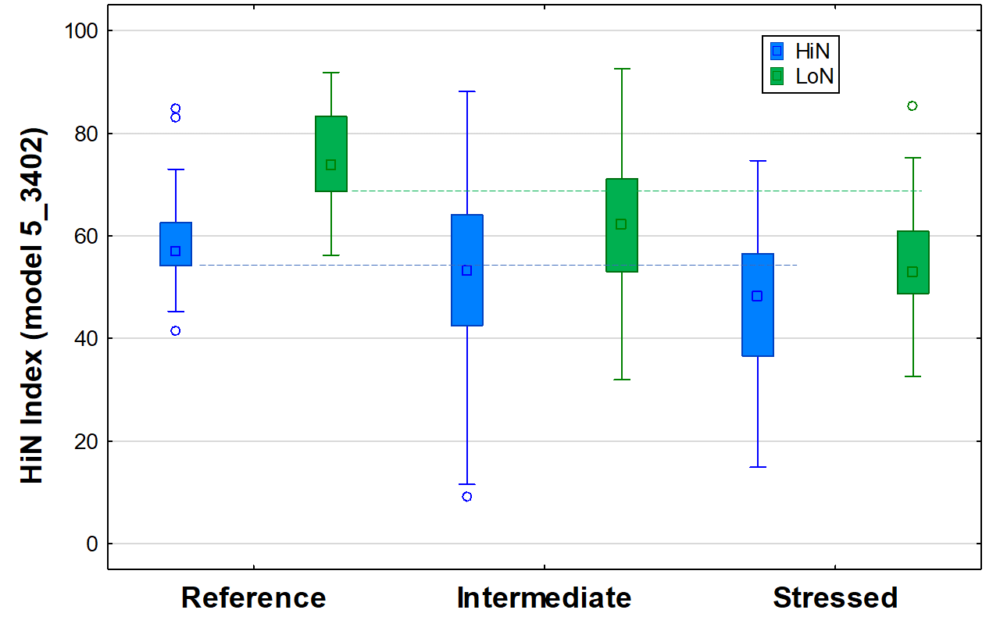

Figure 14. HiN calibration index value distributions by disturbance category and site class. This index was calibrated to the HiN site class (blue). LoN values are shown for comparison and interpretation in case of a mis-identified site class. The dotted horizontal lines are the 25th percentiles of reference sites in each site class, which was used in calculating the discrimination efficiency.

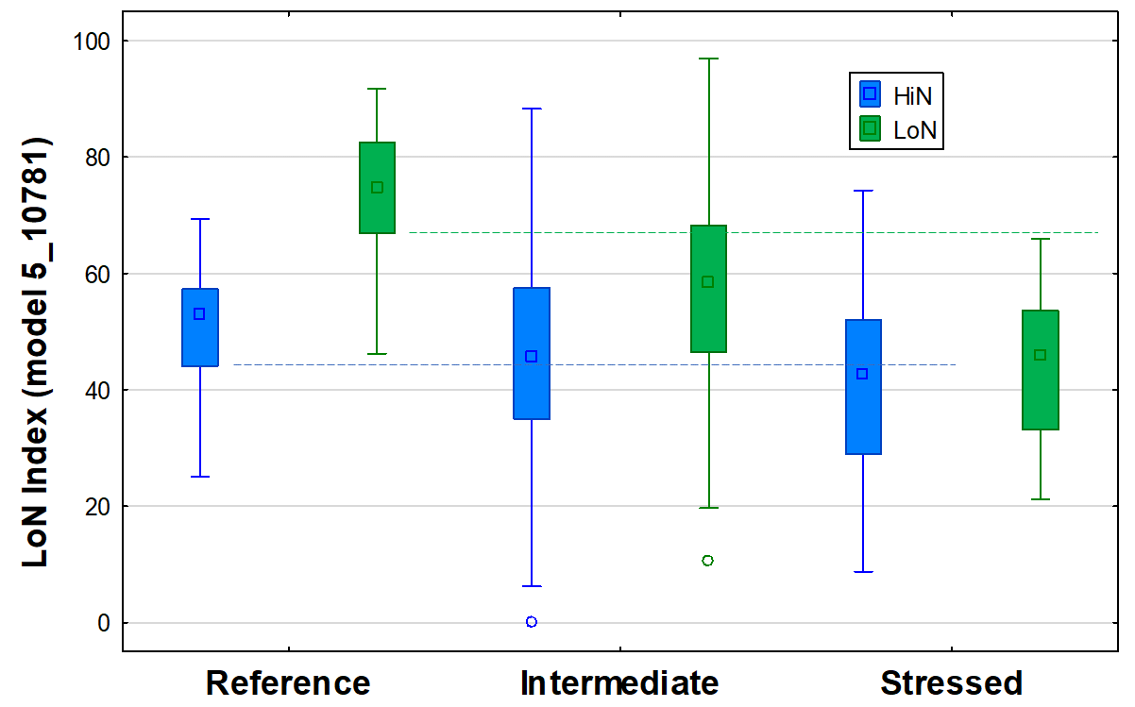

Figure 15. LoN calibration index value distributions by disturbance category and site class. This index was calibrated to the LoN site class (green). HiN values are shown for comparison and interpretation in case of a mis-identified site class. The dotted horizontal lines are the 25th percentiles of reference sites in each site class, which was used in calculating the discrimination efficiency.

## 4.6 Validation

Index scores were calculated for the validation samples that were reserved and not used in calibration. Their performance statistics were compared to calibration results. Validation data were expected to perform nearly as well as calibration data, with DEs not more than 10% less than the calibration data. This was evaluated by comparing reference and stressed validation data to the reference calibration 25th percentiles. Validation samples were reserved based in the HiN and LoN site classes. In one validation category, the number of validation samples was < 10, which can result in unreliable validation percentages.

In the HiN site class, 68.2% of 22 stressed validation samples were below the calibration reference 25th percentile (Table 14). Of the 10 HiN reference validation samples, 6 were greater than the 25th percentile of reference calibration samples. This represents a good validation of the HiN index in identifying stressed sites and only a fair validation of the index in identifying reference sites, because the expectation was for at least 65% of validation reference sites to have index values greater than the 25th percentile of calibration reference sites.

In the LoN site class, validation results were similar to results in the HiN site class. All stressed validation index scores were below the 25th percentile of calibration reference values (100% correct designation). However, only 5 of the 10 HiN reference validation samples were greater than the 25th percentile of reference calibration samples (50% correct designation).

Table 14. Index performance statistics (N, DE, and percent of reference validation samples greater than the 25th percentile of reference calibration samples) for validation samples in comparison to calibration DE.

|  |  |  |  |  |  |
| --- | --- | --- | --- | --- | --- |
| Site Class | Calibration DE | Validation Strs N | Validation DE | Validation Ref N | % Validation  Ref > 25th |
| HiN | 71.7% | 22 | 68.2% | 10 | 60% |
| LoN | 100% | 5 | 100% | 10 | 50% |

As an additional validation, Spearman rank correlations were calculated to evaluate the responsiveness of the indices to stressors. The indices had significant and relatively high correlation coefficients with conductivity, chloride, total phosphorus, percent urban and percent impervious cover (Table 15). In the HiN site class, correlations were also relatively strong with turbidity, TKN, and the riffle/run habitat score. In the LoN class, relatively strong correlations were also with benthic chlorophyll a, channel and bank habitat scores, and percent agriculture. Indices were not correlated with drainage area, but they were correlated with air temperature. Scatter plots illustrating these relationships are in Appendix I).

Table 15. Spearman rank correlation coefficients relating the diatom indices to stressors and natural variables within site classes. Values marked with an asterisk (*) were significant at p < 0.05. Values marked with two asterisks (**) were significant at p < 0.01.

|  |  |  |
| --- | --- | --- |
|  | HiN Index (5_3402) | LoN Index (5_10781) |
| DisOxy | -0.02 | -0.04 |
| pH | -0.08 | -0.10 |
| Chloride | -0.34** | -0.62** |
| Conductivity | -0.30** | -0.48** |
| Turbidity | -0.25** | -0.14 |
| N_TKN | -0.39** | -0.24 |
| P_total | -0.48** | -0.55** |
| CHLa_benthic | 0.11 | -0.29** |
| CHLa_water | -0.15* | 0.06 |
| Act_Activity_QHEItotal_Score | 0.09 | 0.14 |
| Substr_Score_Val_Txt | 0.06 | 0.13 |
| Instr_Cover_Score_Val_Txt | 0.12* | -0.05 |
| Chan_Score_Val_Txt | 0.04 | 0.28** |
| Bank_Score_Val_Txt | 0.11 | 0.30** |
| Pool_Score_Val_Txt | 0.02 | -0.07 |
| Riffle_Rif_Run_Score_Val_Txt | 0.15** | 0.18 |
| Gradient_Score_Val_Text | -0.03 | 0.09 |
| W_pcUrban | -0.19** | -0.50** |
| W_pcAg | 0.07 | -0.39** |
| W_pcImp | -0.23** | -0.47** |
| Drainage | -0.13* | -0.04 |
| TmeanWs | -0.21** | 0.33** |

## Index Precision

Index precision was compared among replicate samples collected at the same sites on the same days. The replicates included 69 replicate sets, including 144 total replicates. Analyses were separated by site class (HiN and LoN). We calculated the variability of index scores for the replicated samples as an estimate of index precision related to sampling error and variability (Table 16). Index RMSE values (approximating within site standard deviation) were 9.6 index points in both site classes. The RMSEs were used to calculate the CI90s of 15.8 index points in both site classes.

The 90% CI of 15.8 index points indicates that this amount of difference between index scores would represent a meaningful change in index values when measured in the same year, with 90% confidence. On a 100-point index scale, this precision suggests that 3 – 5 condition levels could be detected in the index when accounting for sampling error. The confidence interval does not apply to any comparisons to condition thresholds, only to comparisons among individual samples.

Table 16**.** Index precision statistics for same-day same-site replicates. Mean squared error (MSE) and root mean squared error (RMSE) values are derived from one-way ANOVA. RMSE is an approximation of standard deviation. Coefficient of variability (CV) was calculated as the RMSE standardized by the Index Mean. The 90% confidence interval (CI90) was calculated as 1.645 * RMSE.

|  |  |  |  |  |  |  |  |
| --- | --- | --- | --- | --- | --- | --- | --- |
| Site Class | N Stations | N Replicates | Index MSE | Index Mean | RMSE | CV | CI90 |
| HiN | 52 | 108 | 92.7 | 48.3 | 9.6 | 20.0 | 15.8 |
| LoN | 17 | 36 | 92.3 | 57.7 | 9.6 | 16.6 | 15.8 |

## 4.8 Condition Thresholds

The distribution of index values in the reference condition can be used in setting thresholds of impairment: How much deviation from the reference condition is the State willing to tolerate under the CWA? How many species is the State willing to lose from a stream assemblage before triggering a management action? Application of thresholds based on the reference distribution of index values must account for the expectations of reference conditions relative to the reference criteria and whether the reference sites represent a minimally disturbed condition or only the least disturbed, or best observed, condition.

The indices were shown to distinguish between reference, intermediate, and stressed sites. Reference index distribution percentiles and associations with Type I and Type II error are shown in Table 17. These statistics were derived from the combined calibration and validation data sets.

Impairment thresholds based on the 10th through 25th percentiles of the reference data sets correspond to 43.2 and 53.1 index points in the HiN site class and 46.7 and 61.9 in the LoN site class. In the HiN site class, The Type I and Type II errors are balanced at the 30th reference percentile; an index score of 54.3. In the LoN site class, the balance of errors occurs at the 20th reference percentile, or 56.9 index points. The difference in index value statistics between the two site classes can be attributed to different index formulations. The difference in index percentiles at the point of balanced error can be attributed to a more sensitive index in the LoN site class.

The standard deviation of the reference HiN index distribution was 10.6 index points. The mean reference index score (58.2) minus 1 standard deviation is 47.6 index points. The standard deviation of the reference LoN index distribution was 13.4 index points. The mean reference index score (70.2) minus 1 standard deviation is 56.8 index points.

Table 17. Diatom index distribution statistics and error associated with reference percentiles.

|  |  |  |  |  |  |  |
| --- | --- | --- | --- | --- | --- | --- |
| Statistic | All sites index score | Reference index score | Type I error (%) | DE (%) | Type II error (%) | All Below (%) |
| HiN |  |  |  |  |  |  |
| Valid N | 323 | 37 |  | 68 |  | 323 |
| Minimum | 8.9 | 38.3 | 0 | 35.3 | 64.7 | 19.8 |
| 5th Percentile | 24.3 | 40.7 | 2.7 | 39.7 | 60.3 | 23.8 |
| 10th Percentile | 32.7 | 43.2 | 8.1 | 45.6 | 54.4 | 28.8 |
| 15th Percentile | 35.5 | 50.3 | 13.5 | 57.4 | 42.6 | 44.0 |
| 20th Percentile | 38.3 | 51.7 | 18.9 | 63.2 | 36.8 | 47.7 |
| Lower Quartile | 41.4 | 53.1 | 24.3 | 67.6 | 32.4 | 51.1 |
| 30th Percentile | 43.5 | 54.3 | 29.7 | 70.6 | 29.4 | 55.7 |
| Mean | 51.9 | 58.2 | 62.2 | 76.5 | 23.5 | 66.9 |
| Median | 53.0 | 56.8 | 48.6 | 73.5 | 26.5 | 62.8 |
| Upper Quartile | 61.8 | 62.6 | 73.0 | 85.3 | 14.7 | 75.5 |
| Maximum | 88.1 | 84.6 | 97.3 | 98.5 | 1.5 | 98.8 |
| LoN |  |  |  |  |  |  |
| Valid N | 112 | 24 |  | 16 |  | 112 |
| Minimum | 0 | 45.2 | 0 | 50.0 | 50 | 23.2 |
| 5th Percentile | 23.0 | 46.2 | 4.2 | 56.3 | 43.7 | 24.1 |
| 10th Percentile | 37.3 | 46.7 | 8.3 | 56.3 | 43.7 | 25.9 |
| 15th Percentile | 41.1 | 52.8 | 12.5 | 68.8 | 31.2 | 37.5 |
| 20th Percentile | 44.3 | 56.9 | 16.7 | 81.3 | 18.7 | 45.5 |
| Lower Quartile | 46.3 | 61.9 | 25.0 | 93.8 | 6.2 | 55.4 |
| Mean | 57.5 | 70.2 | 41.7 | 100 | 0 | 75.0 |
| Median | 58.5 | 72.5 | 50.0 | 100 | 0 | 79.5 |
| Upper Quartile | 70.2 | 78.7 | 75.0 | 100 | 0 | 90.2 |
| Maximum | 96.7 | 91.9 | 95.8 | 100 | 0 | 98.2 |

A synopsis of the possible index thresholds to describe a general distinction between acceptable and degraded biological conditions is shown in Table 18. In both site classes, the potential threshold derived from a balancing of Type I and Type II errors is corroborated by one other analytical result. In the HiN site class, the 25th percentile of reference site index values is a strong candidate for a threshold because the use of this statistic for setting condition thresholds has precedent in the literature and the errors are nearly balanced. The reference 25th percentile (53.1 index points) is the median of the thresholds derived in the analyses. The threshold derived from the balanced errors (54.3 index points) is also a potential threshold, though it is the 30th percentile of reference.

In the LoN site class, the balanced errors and the 20th percentile of reference sites (56.9 index points) coincide with the mean of reference minus one standard deviation. The mean minus one standard deviation is a descriptive threshold that allows statistical conceptualization of the core reference values and the departure from them.

The 75th percentile of all sites is a high outlier of the potential thresholds identified in both site classes. This threshold is based on an assumption that approximately 75% of the general population of sites have a degraded biological condition. This assumption is not supported by the other threshold-setting methods that have a basis in the reference condition concept. The 10th percentile of reference sites is the low end of the range of possible thresholds in both site classes.

Table 18. Diatom index thresholds resulting from reference distributions and balancing Type I and Type II errors.

|  |  |  |
| --- | --- | --- |
| Threshold Rationale | Corresponding HiN Index Value | Corresponding LoN Index Value |
| Reference 10th percentile | 43.2 | 46.7 |
| Reference 25th percentile | 53.1 | 61.9 |
| Reference mean minus one standard deviation | 47.6 | 56.8 |
| Balanced Type I and Type II errors | 54.3 | 56.9 |
| 75th percentile of all sites | 61.8 | 70.2 |

Within the generally acceptable index ranges (above the suggested general threshold), Exceptional and Satisfactory conditions could be distinguished based on a bisection of the unimpacted index range, half-way between the general threshold and the maximum of the index scale. For the preliminary index thresholds of 53.1 in the HiN and 56.9 in the LoN, these secondary thresholds would be at 76.5 and 78.5, respectively. Similarly, the impacted range of the index scale could be bisected into Moderately Degraded and Severely Degraded conditions at secondary thresholds of 26.6 and 28.5 for the HiN and LoN indices, respectively.

Based on proportional odds logistic regression, a threshold between Exceptional and Satisfactory conditions was identified at 82 index points for the LoN diatom index. The threshold between Moderately Degraded and Severely Degraded conditions was identified at 26 LoN index points (Figure 16). The crossover for stressed and reference membership probabilities is at 54 LoN index points. We have less confidence in this as a potential general threshold because of the influence of the mid-stress distribution. Because of the broad distribution of index values in the HiN intermediate and stressed disturbance categories, the proportional odds logistic regression results were unintelligible; the cross-over values with the intermediate distribution were outside of the 100-point scale.

These indications from reference distributions, standard deviations, and balanced errors suggest that a general condition threshold dividing satisfactory conditions from moderately degraded conditions should be in the range of 53 - 57 index points, depending on site class (Table 19 and Figure 17). Secondary thresholds are 76 – 82 index points to describe Exceptional and Satisfactory conditions within the acceptable index range and 26 - 27 to describe Moderately Degraded and Severely Degraded conditions.



Figure 16. Proportional odds logistic regression graph for the LoN index, showing probability of membership in the reference (1), moderately stressed (2), and highly stressed (3) disturbance categories. Actual data points for the revised index are plotted at the top of the graph.

Table 19. Threshold ranges and recommended index values for indication of biological conditions in Indiana streams.

|  |  |  |  |  |  |  |  |  |  |
| --- | --- | --- | --- | --- | --- | --- | --- | --- | --- |
|  |  | General unimpacted conditions | | | | General impacted conditions | | | |
|  |  | Exceptional Conditions | | Satisfactory Condition | | Moderately Degraded Condition | | Severely Degraded Condition | |
| HiN | Index threshold range |  | 76.5 | | 43.2 – 61.8 | | 26.6 | |  |
| HiN | Suggested index threshold |  | 76.5 | | 53.1 | | 26.6 | |  |
| LoN | Index threshold range |  | 78.5 - 82 | | 49.7 – 70.2 | | 26 - 28.5 | |  |
| LoN | Suggested index threshold |  | 82 | | 56.9 | | 26 | |  |



Figure 17. Indiana diatom index value distributions in disturbance categories for the HiN (left) and LoN (right) site classes, showing suggested condition thresholds and the range of possible values for the general condition threshold.

The map in Figure 18 shows the spatial distribution of sites in the four biological condition categories based on the recommended thresholds. These thresholds are preliminary and are subject to further review, refinement, and approval by IDEM before they are applicable in biological assessment programs.

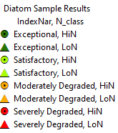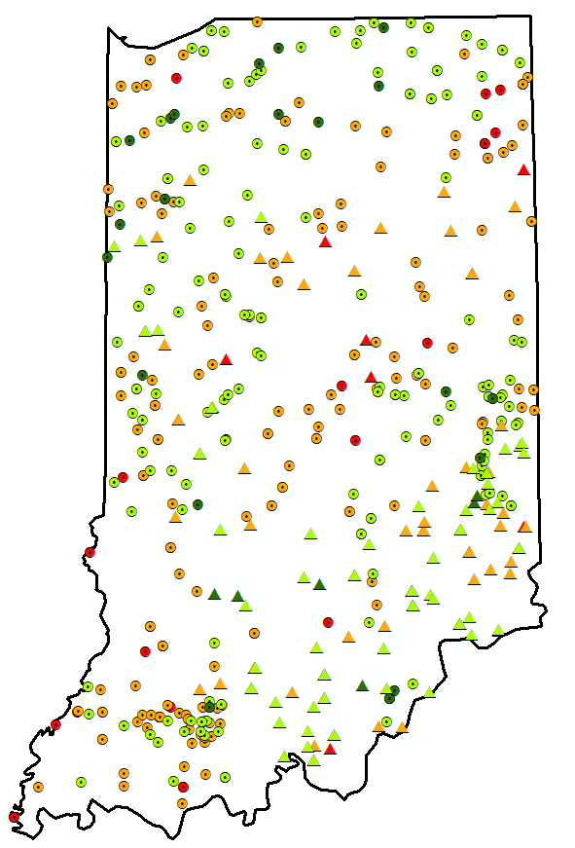

Figure 18. Indiana diatom sites color-coded by biological condition category based on the recommended IBI thresholds in Table 19, also showing site classes.

# Conclusions, Discussion, and Recommendations

## 5.1 Conclusions

The multimetric diatom index developed for Indiana streams is calibrated to the natural background settings and is efficient at indicating diatom conditions relative to stressors. The main influence on the diatom assemblage was identified as geologic sources of nitrogen. This was used to define site classes HiN and LoN. In general, the metrics that were responsive to the stressor gradient had optimal values when background nitrogen was low. When background nitrogen was high, the diatom metrics were suboptimal. This natural factor should be considered if using the diatom indices in relation to nutrients either as stressors or as natural conditions.

The indices (in both low and high background nitrogen) were responsive to the general disturbance gradient that was identified largely from land use cover and activities. The index as calibrated to this gradient was successfully validated with independent data. The validation was especially successful at correctly identifying stressed sites. The error associated with identifying least-disturbed reference sites was higher in the validation data than it was in the calibration data. When compared to some of the stressors that were not used in defining the disturbance categories, the indices showed responses to salts (conductivity and chloride) and to nutrients (TKN and total phosphorus). Depending on the site class, the indices were also responsive to turbidity and habitat features. The index was also responsive to long term air temperature; negatively correlated in the HiN site class and positively correlated in the LoN.

The index was more responsive to the stressor gradient in low nitrogen background settings (the LoN site class) than it was with higher background nitrogen (HiN). This might be attributed to the natural effect of nutrients, which are typically understood as stressors in the context of algal assemblages. With high nitrogen even in reference sites, the metrics showed sub-optimal values over the entire stressor gradient and less of a difference between the least disturbed and most disturbed sites. Differences in index value statistics between the two site classes can also be attributed to different index formulations.

The diatom index will enhance the state of Indiana’s monitoring strategy by adding another core indicator (diatom community structure) used to assess aquatic life use in:

* IDEM’s Integrated Report, thus satisfying CWA 305(b) and 303(d) reporting requirements to EPA.
* Watershed characterization projects which identify critical areas and chemical/physical stressors to the biological communities.
* Identifying improvements in the biological communities following watershed restoration efforts.

## 5.2 Specific metric responses

The metrics included in the indices showed consistent responses to the stressor gradient across the site classes. They were selected based on empirical evidence of the response within the calibration data set, diversity of metric types and traits, and plausible rationale for the response mechanism.

***Nutrient Indicators***

Nutrient concentrations are associated with nutrient based diatom metrics in both site classes of the Indiana data set as well as in other settings (Porter et al. 2008, Pillsbury et al. 2019). Diatom responses to phosphorus include productivity and growth rates and shifts in taxonomic composition from oligotrophic species to those capable of faster growth under P-enriched conditions. For example, the low phosphorus diatom metric has been shown to decrease substantially at phosphorus concentrations above 75 to 150 µg/L (Smucker et al. 2020). Periphyton responses to phosphorus enrichment precede those of other biota (e.g., emergent macrophytes) and, thus, provide a valuable early indicator of eutrophication, as seen in the Florida Everglades and other wetlands (McCormick and Scinto 1999). Because diatoms have specific tolerance and preference for nutrient conditions, nutrient inference models have been calibrated using nutrient-based taxa traits (Ponader et al. 2007, Kelly and Whitton 1995).

***Achnanthidium and Navicula***

The *Achnanthidium* and *Navicula* genera were defined in thestrict sense for current taxa identifications and calculation of metrics. In other words, the most current genus designations for the taxa were used to identify these genera, even though the taxon name in the database might differ. As an example, *Navicula minima* is identified in the taxa list from IDEM, but is now considered *Eolimna minima,* not in the *Navicula* genus*.* These designations were derived from the USGS/DONA traits table.

*Achnanthidium* and *Navicula* were responsive to the stressor gradient in the Indiana data set and their use as indicators have precedence as indicators, though often at the species level*.* Low-nutrient streams can be dominated by a few small species of *Achnanthidium* (Kawecka 1993; Stevenson et al. 2008b) and increases in nutrient concentrations may increase dominance of other taxa more than the small *Achnanthidium* (Manoylov and Stevenson 2006).

While the genera were responsive as taxa groups it is evident that there is variable sensitivity among species (Ponader and Potapova 2007, Paul et al. 2020, Tang et al. 2016). *Achnanthidium* and *Navicula* are taxa-rich genera with diverse species characteristics. The most responsive *Achnanthidium* and *Navicula* metric forms were related to richness and relative richness. Although some taxa might not be sensitive, as a group, taxa richness of these groups would indicate greater complexity with more sensitive taxa.

***Biological Condition Attributes***

The Biological Condition rating (diatoms.org) takes many factors into account (alkalinity, salinity, organic nutrients, etc.) based on a number of reports (Lange-Bertalot 1979, Van Dam et al. 1994, Bahls 1993, Porter et al. 2008) merged with professional experience following the Biological Condition Gradient (BCG) approach (Davies and Jackson 2006, Paul et al. 2020). The BC traits were established by staff at the EPA and USGS working with diatom taxa traits for the Diatoms of North America website (diatoms.org).

For the index metrics, the proportional richness of BC 1 and BC 2 taxa was responsive along the stressor gradient. BC_1 represents the most sensitive diatoms and BC_2 represents moderately sensitive taxa. The scale is up to BC_5, the most tolerant taxa. In the BCG framework, the most sensitive and moderately sensitive taxa are proportionally diverse when environmental conditions are as naturally occurs. As stressors increase, the sensitive diatom taxa perish or emigrate, resulting in proportionally fewer BC 1 and BC 2 taxa (Hausmann et al. 2016, Paul et al. 2020, Charles et al. 2019).

The BC metric was adjusted to the BFI in the HiN site class and was recognized as having a unique reference distribution in the LoN site class (Figure 19). The metric adjustment for the index in the HiN site class was the residual of the metric value minus 0.15 metric units if the BFI was > 30 BFI units. If the BFI was < 30, the residual was calculated as the metric value minus 0.10 metric units.

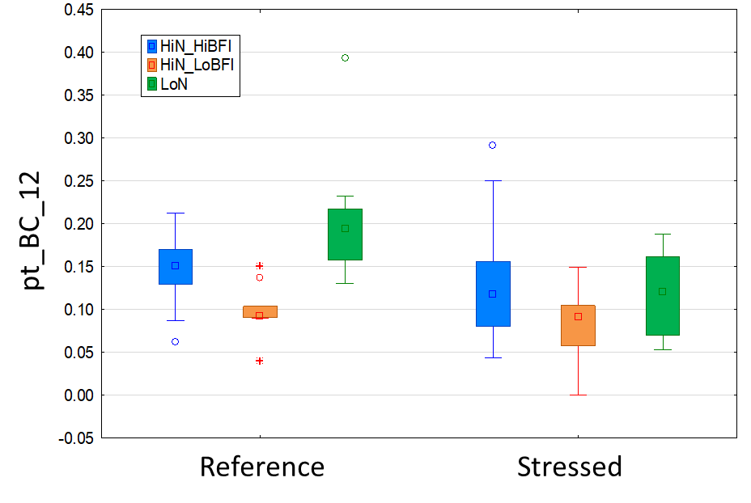

Figure 19. Distributions of the proportion of BC 1 or 2 taxa metric (pt_BC_12) by disturbance category, site class, and base-flow index (BFI) category.

***Pollution Tolerance***

The pollution tolerance system of Lange-Bertalot (1979) was based on a four-year study of the Rhine-Main river system in Germany. At the time, the river was the most polluted river in Central Europe. Water was not treated until 1975 and included effluent of the paper industry. This trait includes some overlap with the saprobian system, which is largely based on biological oxygen demand. PT_1 represents taxa that are very tolerant of extremely degraded conditions and PT_5 represents taxa that are found in water with low organic enrichment. The metric format used in the HiN site class calculates the proportion of taxa that are tolerant and very tolerant of extremely degraded conditions.

***Sensitivity Metrics***

The sensitivity values for common taxa were derived from the tolerance analysis that compared taxa occurrence and abundance in relation to four stressors, including the QHEI habitat score, percent watershed imperviousness, the index of watershed integrity, and measured stream conductivity (Appendix B). The analysis was specific to the Indiana data set. This has the advantage of calibrating taxa sensitivity to the stressors of concern and the taxa commonly collected. There might be disadvantages to defining sensitivity specifically within Indiana (excluding regional conditions and distributions) and to focusing on common taxa. However, the sensitivity metrics were responsive to the disturbance gradient and were included in the indices for both site classes. In the HiN, the proportion of valves that were tolerant (pi_Tol_13) were indicators of the disturbance gradient. In the LoN, the proportion sensitive taxa (pt_Sens_810) were indicators.

***Sestonic Habit Attributes***

Metrics related to traits for general habitat, nitrogen fixation, motility, and cell size are documented in the autecology section of Diatoms of North America (diatoms.org). Sestonic species are primarily suspended in the plankton and include species that are found in lentic habitats of lakes, reservoirs, or slow moving rivers. Benthic species are primarily bottom dwellers, or species that are attached to surfaces.

In this analysis, taxa with sestonic habits were more common in samples from stressed sites than they were in samples from reference sites. Although it was responsive in smaller sites (<500 sq mi), it was not used because it was consistently high in larger sites, for which there were no comparable reference sites. In addition, this metric does not have obvious precedent in the literature as an indicator of general disturbance or as a component of a multi-metric index.

***Chloride Indicator***

The chloride tolerance metric had a very limited range of values, being especially low in reference samples. The tolerant taxa included 16 species, 10 of which were in the genera *Nitzchia* and *Navicula* (Potapova and Charles 2003). These chloride tolerant species were almost entirely absent in reference sites with low background nitrogen. The metric had greater percentages in stressed sites in the LoN site class, so it was more responsive in that class. Diatom community changes have been noted in association with increases in chlorides due to urbanization and road salting (Porter-Goff et al. 2013, Newall and Walsh 2005). Salt tolerant diatoms have been found to increase in catchments influenced by land use, including agriculture and urbanization (Leland & Porter, 2000, Rott et al., 1998; Munn et al., 2002, Sonneman et al. 2001, Potapova and Charles 2003). The metric was not selected for the final index because of the low range of values.

## 5.3 Index response to nutrients

The diatom index will provide a more accurate assessment of ecological effects, thus improving IDEM’s diagnostic ability to identify causes of degradation in water quality. Diatoms are commonly associated with nutrient availability (Charles et al. 2019, Haussman et al. 2016, Justus 2010, Ponader et al. 2007, Porter et al. 2008, Stevenson et al. 2008b). The IDEM diatom IBI might become useful to evaluate direct biological responses to excessive nutrients. The relationship of the diatom IBI and nutrients was explored to begin understanding whether this relationship might be strong enough to be used in establishing nutrient criteria for streams throughout Indiana. The proof-of-concept analysis is preliminary and should not yet be interpreted as recommendations for nutrient thresholds. A complete and varied analysis might be warranted to confirm and refine these preliminary findings.

The analysis included a simple correlation analysis followed by a change-point analysis (CPA, Paul and McDonald 2005). The data included all samples (regardless of reference status and replication) in the LoN (N=126) and HiN (N=370) site classes. Spearman rank correlation *rho* values were calculated between the diatom index and predictor variables related to both stressors and natural variables, including nutrients (TP, TN, NO3NO2, and TKN). The CPA identifies the point on the x-axis (nutrients) at which response variables (index values) are the most disparate (homogenous within each side of the point and different on either side of the point. The change-point (CP) was evaluated using precision of the confidence interval (derived through bootstrap iterations) and confirmation of the LOESS slope with the 95th quantile slope. A draft index (Carlisle et al. [in review]) developed from National Water Quality Assessment (NAWQA) and National River and Stream Assessment (NRSA) data was included in the analysis in addition to the index developed for IDEM.

Results are presented by site class, starting with the LoN. Based on the Spearman *rho* correlation coefficients, the LoN diatom index is sensitive to stressors, especially chloride, conductivity, solids, TP, some metals, and land uses (especially urban development) (Table 20). The LoN index is not very sensitive to nitrogen. The index is also related to natural variables, with somewhat higher index values in warmer, wetter watersheds. Compared to the IDEM-calibrated index, the NAWQA/NRSA MMI is more sensitive to nitrogen, site characteristics, climate factors, and agriculture. Plots of the LoN diatom index against nutrients show that the relationship with total phosphorus (TP) is stronger than with total nitrogen (TN) (Figure 20).

Table 20. Spearman rank correlation coefficients (rho) to show relationships between the IDEM LoN diatom index (LoN_5_10781), the NAWQA/NRSA index (NRSA_MMI), and selected site and water quality variables (see variable code descriptions in Appendix F). Coefficients are shown in bold type to emphasize the stronger relationships. Variables with correlation coefficients |rho| < 0.30 for both indices are not shown.

|  |  |  |  |  |  |
| --- | --- | --- | --- | --- | --- |
| **Variable** | **LoN_5_**  **10781** | **MMI_**  **NRSA** | **Variable** | **LoN_5_**  **10781** | **MMI_**  **NRSA** |
| MMI_NRSA | ***0.56*** | ***1.00*** | Solids_TDS | ***-0.43*** | ***-0.36*** |
| LoN_5_10781 (Index) | ***1.00*** | ***0.56*** | Solids_tot | ***-0.49*** | ***-0.44*** |
| WsAreaSqKm | -0.03 | -0.02 | N_NO3NO2 | -0.11 | ***-0.32*** |
| Elev_m | -0.26 | ***-0.45*** | P_total | ***-0.55*** | ***-0.45*** |
| SLOPE | 0.09 | 0.19 | Cadmium_diss | 0.04 | ***0.31*** |
| WetIndexCat | ***-0.41*** | ***-0.57*** | Cadmium_tot | 0.10 | ***0.39*** |
| WetIndexWs | ***-0.39*** | ***-0.53*** | Chrom_diss | 0.05 | ***0.30*** |
| BFICat | -0.16 | ***-0.36*** | Chrom_tot | 0.13 | ***0.43*** |
| BFIWs | -0.15 | ***-0.38*** | COD | ***-0.37*** | -0.22 |
| MgOCat | -0.20 | ***-0.43*** | Copper_diss | -0.26 | ***-0.35*** |
| MgOWs | ***-0.30*** | ***-0.48*** | Copper_tot | ***-0.36*** | ***-0.34*** |
| NCat | -0.20 | ***-0.41*** | Lead_diss | 0.04 | ***0.33*** |
| NWs | -0.23 | ***-0.44*** | Lead_tot | 0.12 | ***0.38*** |
| PrecipCat | ***0.38*** | ***0.55*** | Magnesium | -0.23 | ***-0.37*** |
| TmaxCat | ***0.32*** | ***0.62*** | Nickel_diss | ***-0.42*** | ***-0.42*** |
| TmeanCat | ***0.31*** | ***0.61*** | Nickel_tot | ***-0.31*** | -0.20 |
| TminCat | ***0.34*** | ***0.59*** | Selenium_tot | 0.10 | ***0.39*** |
| PrecipWs | ***0.39*** | ***0.55*** | Silver_diss | -0.04 | ***-0.31*** |
| TmaxWs | ***0.32*** | ***0.62*** | Silver_tot | -0.07 | ***-0.33*** |
| TmeanWs | ***0.30*** | ***0.60*** | Zinc_diss | ***-0.35*** | -0.23 |
| TminWs | ***0.32*** | ***0.60*** | Zinc_tot | ***-0.33*** | 0.01 |
| Alkalinity | -0.19 | ***-0.33*** | W_pcUrban | ***-0.50*** | -0.29 |
| Chloride | ***-0.62*** | ***-0.34*** | W_pcAg | ***-0.37*** | ***-0.42*** |
| Conductivity | ***-0.48*** | ***-0.40*** | W_pcImp | ***-0.47*** | -0.24 |



Figure 20. LoN diatom index values in comparison to TP (top) and TN (bottom), with reference sites marked.

The CPA indicates that there is an important shift to lower LoN index values when TP exceeds 0.061 mg/L (Figure 21). The LOWESS regression line at the CP is negative and is confirmed with a similar slope of the 95th quantile regression line. The CP for TP derived from the NAWQA/NRSA index was similar, at 0.074 mg/L. A log-linear regression interpolation of the index value from TP suggests that the TP CP is associated with a LoN index value of 53.3 mg/L (LoN_5_10781 = 16.361 - 30.372 * log(0.061)). This interpolated index value compares to the index threshold of 56.9 index points, as suggested through multiple analysis in Section 4.8. Through back-calculation with the same regression equation, the 56.9 index value is associated with 0.046 mg/L TP.

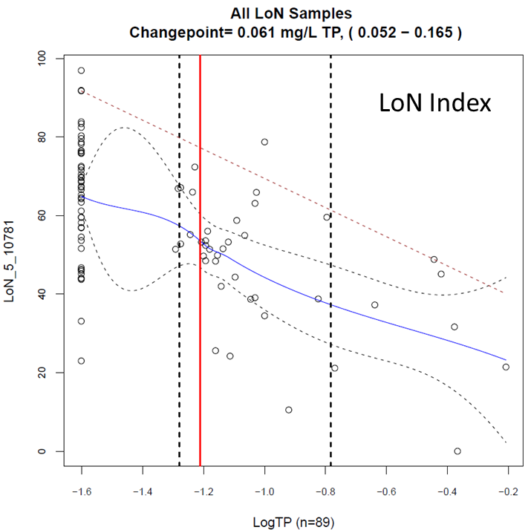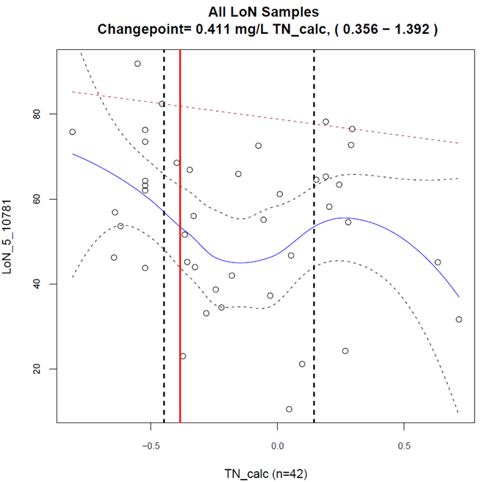

Figure 21. Change-point analysis (CPA) plots to illustrate the relationships between the LoN diatom index and TP (left) and TN (right). Vertical lines and the change-points (CP) and 90% confidence intervals. Blue curves are the LOWESS regression line with dashed confidence envelopes. The dashed slope is the 95th quantile regression line.

Therefore, when LoN diatom index values are below 56.9, biological impairment was suggested based on the recommended diatom index threshold. When LoN index values are below 53.3, biological impairment is commonly associated with high TP (> 0.061 mg/L TP). When TP is greater than 0.046 mg/L, biological impairment is suggested (on average), but might not be due to excess nutrients until TP is greater than 0.061 mg/L.

The same analysis was used to relate the LoN diatom index to TN values, though the correlation coefficient suggested a relatively weak relationship (*rho* > -0.30). In addition, the LOWESS regression slope varied over the nutrient gradient and the NAWQA/NRSA index was even less convincing (contradictory 95th quantile value). Nevertheless, the CP of the two indices were fairly close, ranging from 0.411 to 0.431 mg/L TN. The regression analysis showed agreement between the index threshold (56.9 index units) derived in Section 4.8 and as interpolated (57.3 = 52.794 - 11.731 * log(0.411)). Through back-calculation with the same regression equation, the 57.3 index value is associated with 0.45 mg/L TN.

When LoN index values are below 56.9, biological impairment was suggested based on the recommended diatom index threshold. When LoN index values are below 57.3, biological impairment is commonly associated with high TN (> 0.41 mg/L TN). When TN is greater than 0.45 mg/L, biological impairment is suggested (on average), and might be due to high TN. However, TN was not highly correlated with the LoN diatom index nor the NRSA MMI. Also, CPs are always identifiable regardless of ecological significance

The analysis was repeated in the HiN site class. The HiN diatom index was correlated to stressors, including TP, TKN, chloride, conductivity, solids, some metals, and imperviousness (though weakly) (Table 21). Relative to the HiN index, the NAWQA/NRSA MMI was more sensitive to imperviousness, watershed area, slope, and carbon. The HiN diatom index values were related to natural conditions, with somewhat higher values in watersheds with high groundwater input (high BFI) and low modeled summer stream temperature (MSST). Neither index was sensitive to agricultural land cover. Plots of the HiN diatom index against nutrients show that the relationship with total phosphorus (TP) is stronger than with total nitrogen (TN) (Figure 22).

Table 21. Spearman rank correlation coefficients (rho) to show relationships between the IDEM LoN diatom index (HiN_5_3402), the NAWQA/NRSA index (NRSA_MMI), and selected site and water quality variables (see variable code descriptions in Appendix F). Coefficients are shown in bold type to emphasize the stronger relationships. Variables with correlation coefficients |rho| < 0.30 for both indices are not shown.

|  |  |  |
| --- | --- | --- |
|  | HiN_5_  3402 | MMI_  NRSA |
| MMI_NRSA | 0.55 | 1.00 |
| HiN_5_3402 | 1.00 | 0.55 |
| WsAreaSqKm | -0.11 | ***-0.35*** |
| Elev_m | 0.19 | 0.05 |
| SLOPE | 0.13 | ***0.36*** |
| BFICat | ***0.35*** | 0.14 |
| BFIWs | ***0.31*** | 0.08 |
| Avg_MSST | ***-0.30*** | ***-0.32*** |
| Chloride | ***-0.35*** | ***-0.32*** |
| Conductivity | ***-0.30*** | -0.22 |
| N_TKN | ***-0.39*** | ***-0.39*** |
| P_total | ***-0.48*** | ***-0.41*** |
| C_tot_inorg | ***-0.36*** | ***-0.47*** |
| C_tot_partic | ***-0.36*** | ***-0.47*** |
| Chrom_diss | ***-0.30*** | -0.21 |
| Copper_diss | ***-0.31*** | -0.28 |
| Copper_tot | ***-0.32*** | -0.28 |
| Nickel_diss | ***-0.40*** | ***-0.36*** |
| Nickel_tot | *-0.37* | *-0.36* |
| W_pcImp | -0.24 | ***-0.32*** |

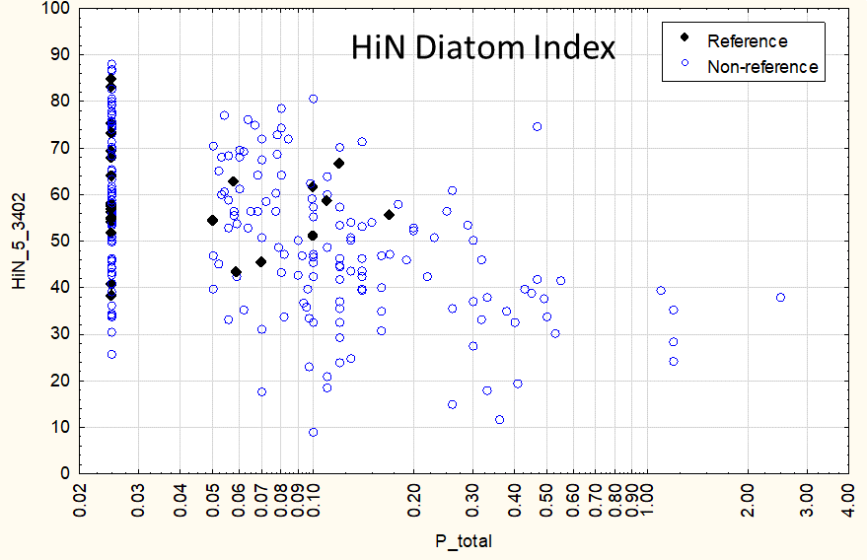

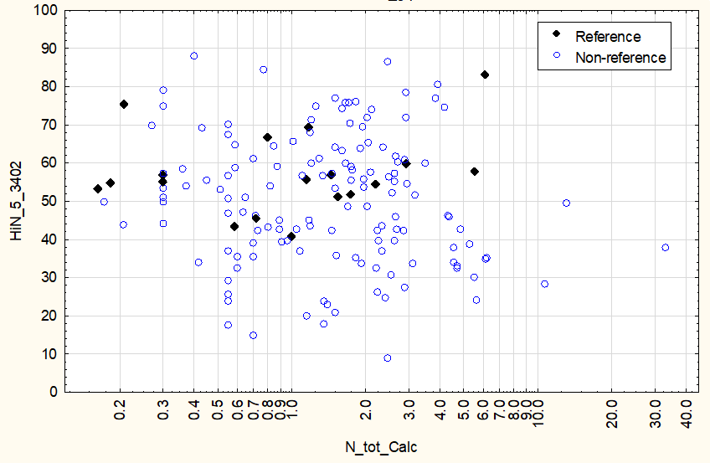

Figure 22. HiN diatom index values in comparison to TP (top) and TN (bottom), with reference sites marked.

The CPA indicates that there is an important shift to lower HiN index values when TP exceeds 0.083 mg/L (Figure 23). The LOWESS regression line at the CP is negative and is confirmed with a similar slope of the 95th quantile regression line. In addition, the confidence interval around the CP is relatively narrow. The CP for TP derived from the NAWQA/NRSA index was similar, at 0.069 mg/L. A log-linear regression interpolation of the index value from TP suggests that the TP CP is associated with a HiN index value of 50.9 mg/L (HiN_5_3402 = 31.6193 - 17.823 * log(0.083)). This interpolated index value compares to the index threshold of 53.1 index points, as suggested through multiple analysis in Section 4.8. Through back-calculation with the same regression equation, the 50.9 index value is associated with 0.062 mg/L TP.

Therefore, when HiN diatom index values are below 53.1, biological impairment was suggested based on the recommended diatom index threshold. When HiN index values are below 50.9, biological impairment is commonly associated with high TP (> 0.083 mg/L TP). When TP is greater than 0.062 mg/L, biological impairment is suggested (on average), but might not be due to excess nutrients until TP is greater than 0.083 mg/L.

The HiN diatom index was not strongly related to TN values (*rho* = -0.16) but there was a stronger correlation with TKN. TKN is not typically used in nutrient criteria, but it is a major component of TN, with nitrate and nitrite. The CPA analysis with the HiN diatom index and TKN showed that there was an important shift in HiN index values when TKN exceeded 0.42 mg/L. A CPA with the NAWQA/NRSA index indicated a similar CP of 0.39 mg/L TKN. The regression analysis showed agreement between the index threshold (53.1 index units) derived in Section 4.8 and as interpolated (52.3 = 44.329 - 20.956 * log(0.415)). Through back-calculation with the same regression equation, the 52.3 index value is associated with 0.42 mg/L TKN.

When HiN index values are below 53.1, biological impairment was suggested based on the recommended diatom index threshold derived in Section 4.8. When HiN index values are below 52.3, biological impairment is commonly associated with high TKN (> 0.42 mg/L). If TKN would be used in nutrient criteria instead of TN, it could be supported with a CPA. However, the lack of a strong relationship with TN would need further exploration.

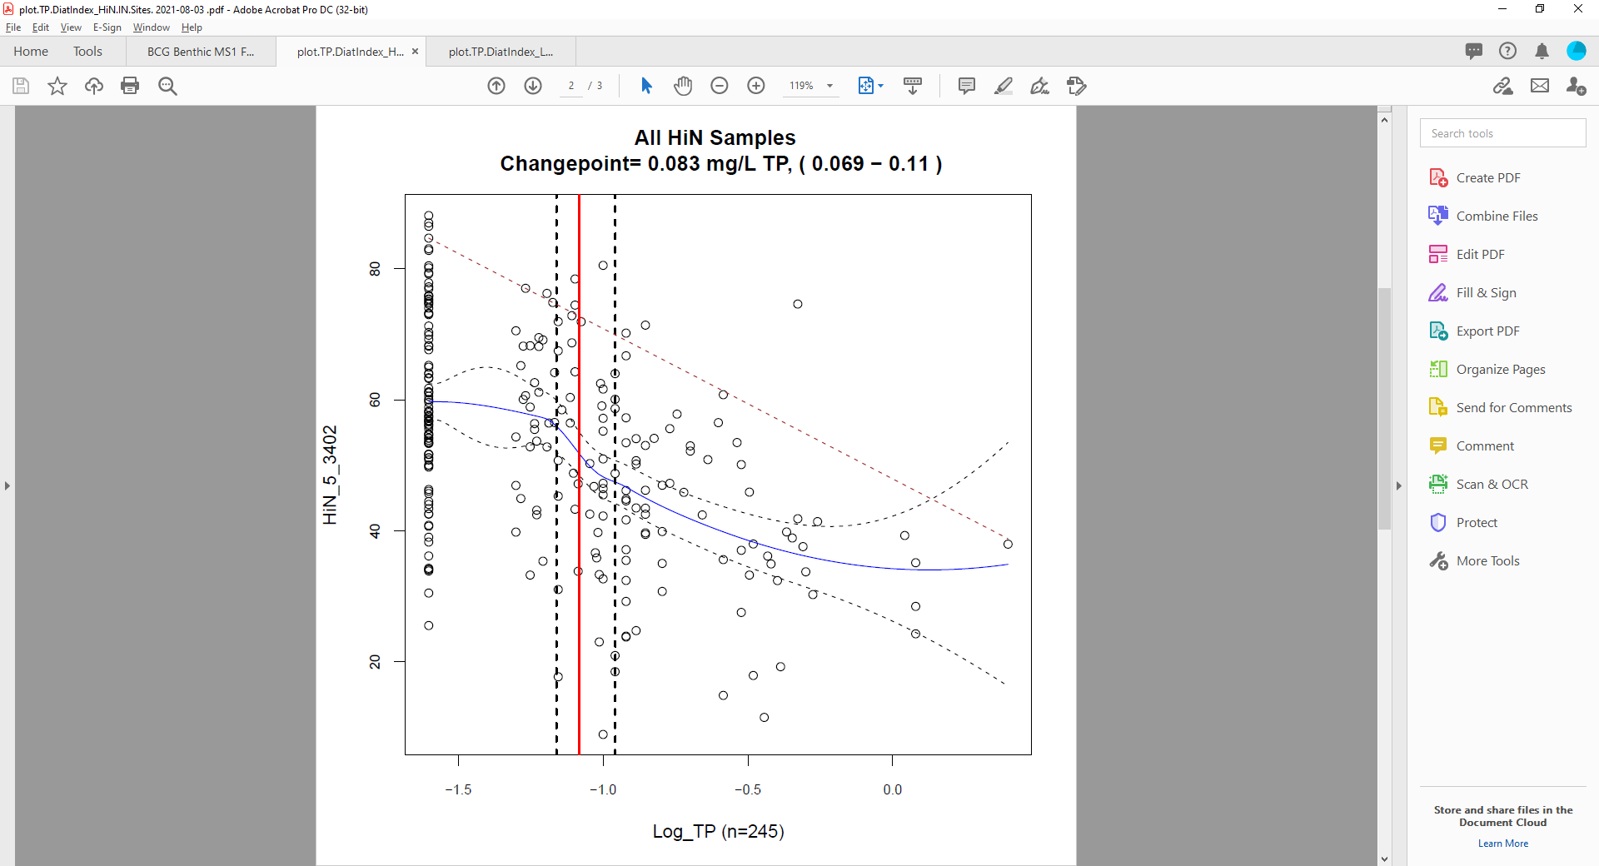 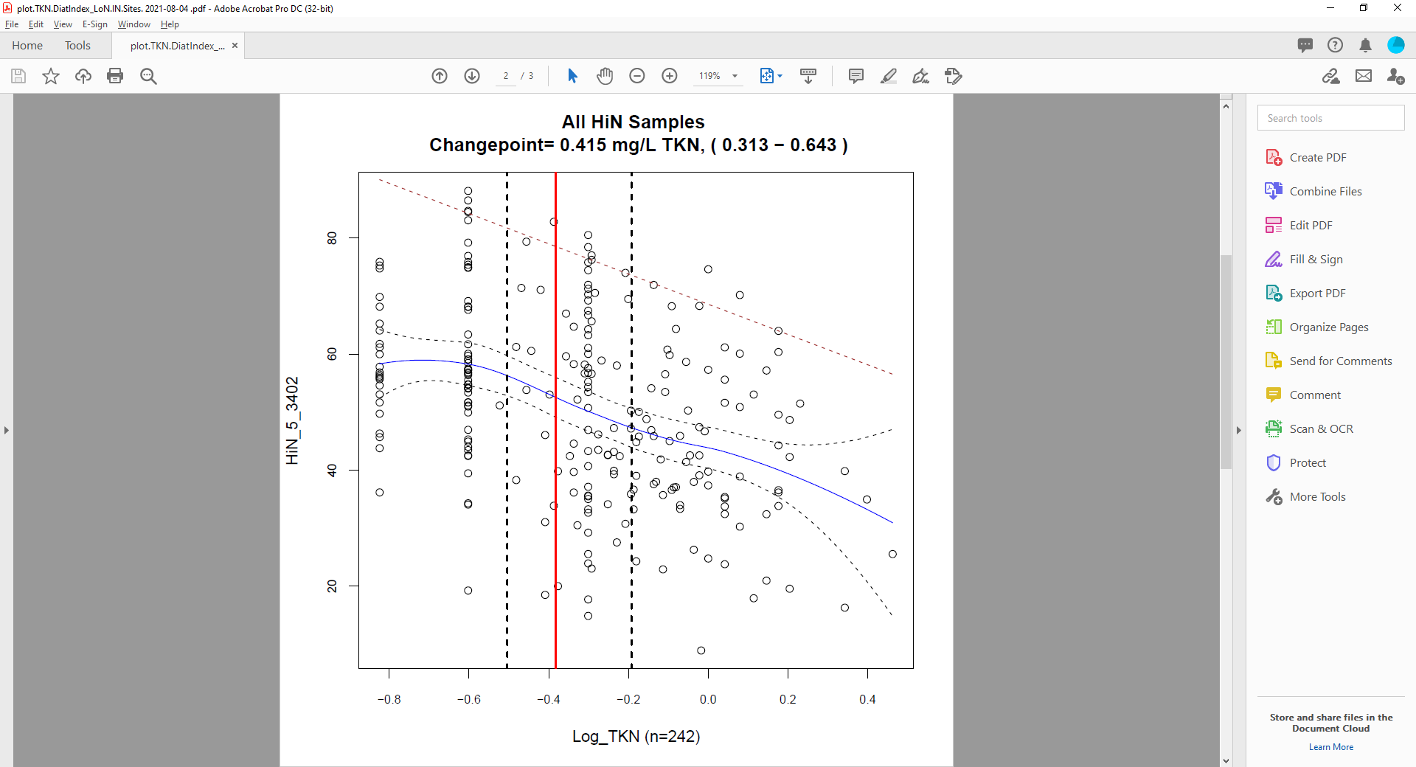

Figure 23. Change-point analysis (CPA) plots to illustrate the relationships between the LoN diatom index and TP (left) and TN (right). Vertical lines and the change-points (CP) and 90% confidence intervals. Blue curves are the LOWESS regression line with dashed confidence envelopes. The dashed slope is the 95th quantile regression line.

The nutrient CP at which the diatom indices show the greatest differences in values are closely associated with the diatom index thresholds of impairment derived through other methods in Section 4.8. Below identifiable diatom index values, TP concentrations are higher and might contribute to or signal biological impairment. Diatom index associations with TN are not as robust, or not evident, compared to associations with TP. The LoN diatom index was more responsive to stressors than the NRSA MMI, with the exception of some metals and NO3NO2. The HiN diatom index was more responsive to stressors than the NRSA MMI, with the exception of carbon and % imperviousness. These analyses show potential for using the diatom index as one line of evidence in evaluating direct biological responses to excessive nutrients.

The nutrient benchmarks identified in this preliminary analysis are comparable to nutrient benchmarks identified through diatom analyses in other states, such as New Jersey (Charles et al. 2019, Hausmann et al. 2016) and Ohio (Smucker et al. 2020). The New Jersey nutrient benchmarks were derived by comparison to Level 4 of the Biological Condition Gradient (Davies and Jackson 2006). For the Ohio study in the Little Miami River, benchmarks were derived using three nonparametric statistical analyses to characterize change-points in the diatom community relative to nutrients concentrations. Benchmarks for TN as suggested in Ohio was a broad range that included the range suggested in the LoN site in the current study (a TN benchmark was not suggested in the HiN site class) (Table 22). In New Jersey, the TN benchmark was more than double the concentration suggested for the LoN site class. For TP, the other studies suggested benchmarks that spanned the range of (Ohio) and were lower than (New Jersey) the range of benchmarks suggested in the current analysis (Table 22).

Table . Comparison of preliminary nutrient benchmarks in the LoN and HiN site classes with benchmarks suggested for Ohio and New Jersey.

|  |  |  |  |  |
| --- | --- | --- | --- | --- |
| Nutrient | LoN | HiN | Ohio 1 | New Jersey 2 |
| Nitrogen (mg TN/L) | 0.41 – 0.43 | (0.42 TKN 3) | 0.150 – 0.850 | 1.00 |
| Phosphorus (mg TP/L) | 0.061 – 0.074 | 0.069 – 0.083 | 0.020 - 0.150 | 0.050 |

1 Smucker et al. 2020

2 Charles et al. 2019

3 TKN benchmarks were explored in the HiN site class instead of TN

## 5.4 Index Application

Index application for biological assessments depends on consistent collection of samples from valid site types, appropriate calculation and scoring of metrics, combination of metric scores, comparison to approved condition thresholds, and awareness of potential error.

Sample collection and processing must follow protocols according to the Technical Standard Operating Procedures for periphyton sampling (IDEM 2018). Periphyton samples are collected during low flow, from late August through October. The stream sampling frame includes flowing wadeable perennial streams. Except for a few outliers, site watershed ranged from 0.5 – 5,000 sq mi. However, index results might be more reliable in the range of 2 – 500 sq mi, which is the range of most reference site watershed sizes.

Site classes are based on geologic nitrogen composition (NWs [4]). Low nitrogen sites have NWs < 0.089 %.

Taxonomic standards and traits must be as described in the electronic Attachments 1 and 2. Metric calculations should follow the conventions for taxa richness, proportion or percent of taxa, and proportion of valves (individuals). Metric scoring is according to the formulae in Table 13. Metric calculation, scoring, and combination in the indices can be accomplished using the R-Shiny app[5]. This index calculation tool requires input of sample taxa lists with specific formats that are detailed in an instruction page in the R-Shiny app. As the metrics were developed in the R-Shiny app, it became apparent that some traits and some metric calculations needed slight revisions. These revisions were necessary and valid. They were not substantial enough to warrant revisions in analysis (Appendix J).

Index values can be used in assessment for characterizing waterbody biological conditions and for prioritizing management actions. The thresholds for condition categories presented in Table 17 are preliminary until approved by IDEM. Thresholds could be refined in accordance with concepts of the Biological Condition Gradient (BCG; U.S. EPA 2016). Once a threshold is decided, conditions resulting from comparisons of index values to the threshold should be qualified by stating the Type I and Type II errors associated with the thresholds. For simplicity, a general rule of thumb could be applied to associate conditions with indices: Index values > 80 indicate exceptional conditions, 55 – 80 are satisfactory, 25 – 55 are moderately degraded, and < 25 are severely degraded.

When comparing one sample to another, the CI90 in Table 16 can be used to determine whether the index values are significantly different. There is some evidence that least disturbed index values are more precise than scores for non-reference sites (Smucker and Vis 2011), but this was not confirmed with the Indiana data due to low numbers of replicate sets in each category. The CI90 should not be used in comparison to the threshold because the error associated with the threshold is already described using the Type I and Type II errors.

# 6 References Cited

Bahls, L.L. 1993. *Periphyton bioassessment methods for Montana streams*: Water Quality Bureau, Department of Health and Environmental Sciences, Helena, MT, 69 p.

Bailey, R.C., R.H. Norris, and T.B. Reynoldson. 2004. Bioassessment of freshwater ecosystems: using the reference condition approach. Kluwer Academic Publishers, New York.

Barbour, M. T., J. Gerritsen, G.E. Griffith, R. Frydenborg, E. McCarron, J.S. White, and M.L. Bastian. 1996. A framework for biological criteria for Florida streams using benthic macroinvertebrates. *Journal of the North American Benthological Society* 15(2):185-211.

Barbour, M.T., J. Gerritsen, B.D. Snyder, and J.B. Stribling. 1999. Rapid Bioassessment Protocols for Use in Streams and Wadeable Rivers: Periphyton, Benthic Macroinvertebrates and Fish, Second Edition. EPA 841-B-99-002. U.S. Environmental Protection Agency; Office of Water; Washington, D.C.

Blocksom, K.A. 2003. A Performance Comparison of Metric Scoring Methods for a Multimetric Index for Mid-Atlantic Highlands Streams. *Environmental Management,* 31**,** 670-682.

Buss, D. F., D.M. Carlisle, T. S. Chon, J. Culp, J. S. Harding, Keizer-Vlek, J.S. Harding, H.E. Keizer-Vlek, W.A. Robinson, S. Strachan, C. Thirion, and R. M. Hughes. 2014. Stream biomonitoring using macroinvertebrates around the globe: a comparison of large-scale programs. *Environmental Monitoring and Assessment*, 187(1):4132. doi:10.1007/s10661-014-4132-8

Cao, Y., C.P. Hawkins, J. Olson, and M.A. Kosterman. 2007. Modeling natural environmental gradients improves the accuracy and precision of diatom-based indicators. *Journal of the North American Benthological Society* 26(3), 566-585.

Carlisle, D.M., S.A. Spaulding, M.A. Tyree, N.O. Schulte, S.S. Lee, R.M. Mitchell, A.A. Pollard [in review]. Multi-metric Indicators for Assessing the Condition of Stream Diatom Assemblages in the Conterminous United States. Submitted to Ecological Indicators.

Charles D.F., A.P. Tuccillo and T.J. Belton. 2019. Use of diatoms for developing nutrient criteria for rivers and streams: a biological condition gradient approach. *Ecological Indicators* **96:** 258-269.

Cohen, J. 1992. A power primer. *Psychological Bulletin*, 112(1):155.

Davies, S.P., and S.K. Jackson. 2006. The biological condition gradient: a descriptive model for interpreting change in aquatic ecosystems. *Ecological Applications*, *16*(4), pp.1251-1266.

DeShon, J. E. 1995. Development and application of the Invertebrate Community Index (ICI). In: Davis, W.S. and Simon, T.P., Eds., Biological Assessment and Criteria—Tools for Water Resource Planning and Decision Making, Lewis Publ., Boca Raton, 217-244.

Fetscher, A.E., M.A. Sutula, L.B. Busse, and E.D. Stein. 2013. Condition of California perennial, wadeable streams based on algal indicators. *California State Water Resources Control Board Surface Water Ambient Monitoring Program (SWAMP) Final Technical Report*.

Fetscher, A.E., R. Stancheva, J.P. Kociolek, R.G. Sheath, E.D. Stein, R.D. Mazor, P.R. Ode, and L.B. Busse. 2014. Development and comparison of stream indices of biotic integrity using diatoms vs. non-diatom algae vs. a combination *J Appl Phycol* 26:433–450.

Flotemersch, J.E., J.B. Stribling, and M.J. Paul. 2006. Concepts and Approaches for the Bioassessment of Non-wadeable Streams and Rivers. US Environmental Protection Agency, Office of Research and Development.

Frey, D.G. 1977. Biological integrity of water: An historical approach. The Integrity of Water. Proceedings of a Symposium, March 10-12, 1975. U.S. Environmental Protection Agency, Washington D.C.

Gibbs, DA; Bierwagen, B. (2017) Procedures for delineating and characterizing watersheds for stream and river monitoring programs. (EPA/600/R-17/448F). Washington, DC: U.S. Environmental Protection Agency, Office of Research and Development.

Hausmann, S., D.F. Charles, J. Gerritsen and T.J. Belton. 2016. A diatom-based biological condition gradient (BCG) approach for assessing impairment and developing nutrient criteria for streams. *Science of the Total Environment* **562**: 914-927.

Hering, D., R.K. Johnson, S. Kramm, S. Schmutz, K. Szoszkiewicz, and P.F.M. Verdonschot. 2006. Assessment of European streams with diatoms, macrophytes, macroinvertebrates and fish: a comparative metric‐based analysis of organism response to stress. *Freshwater Biology*, *51*(9), pp.1757-1785

Hill, B. H., A.T. Herlihy, P.R. Kaufmann, R.J. Stevenson, F.H. McCormick, and C. Burch Johnson. 2000. Use of periphyton assemblage data as an index of biotic integrity. *Journal of the North American Benthological Society*, *19*(1), 50-67.

Hill, R.A., M.H. Weber, S.G. Leibowitz, A.R. Olsen, and D.J. Thornbrugh. 2016. The Stream-Catchment (StreamCat) Dataset: A Database of Watershed Metrics for the Conterminous United States. *Journal of the American Water Resources Association (JAWRA)* 52:120-128. DOI: 10.1111/1752-1688.12372.

Hughes, R.M., D.P. Larsen, and J.M. Omernik. 1986. Regional reference sites: a method for assessing stream potentials. Environmental Management 10:629–635.

IDEM. 2018. Phytoplankton and Periphyton Field Collection Procedures; Technical Standard Operating Procedure; B-004-OWQ-WAP-XX-18-T-R1. Office of Water Quality. Watershed Assessment and Planning Branch.

IDEM. 2015. Processing and Identification of Diatom Samples; Technical Standard Operating Procedure; B-002-OWQ-WAP-TGM-15-T-R0. Office of Water Quality. Watershed Assessment and Planning Branch.

Jessup, B.K., and J. Stamp 2017. Development of multimetric indices of biotic integrity for assessing macroinvertebrate and fish assemblages in Indiana streams. Prepared for US EPA Region 5 and the Indiana Department of Environmental Management.

Johnson R.K., D. Hering, M.T. Furse and R. Clarke. 2006a. Detection of ecological change using multiple organism groups: metrics and uncertainty. *Hydrobiologia*, 566, 115–137.

Johnson R.K., D. Hering, M.T. Furse and P.F.M. Verdonschot. 2006b. Indicators of ecological change: comparison of the early response of four organism groups to stress gradients. *Hydrobiologia*, 566, 139–152.

Johnson, Z., S. Leibowitz and R. Hill. 2018. Revising the index of watershed integrity national maps. *Science of the Total Environment*. 10.1016/j.scitotenv.2018.10.112.

Justus, B. G., J.C. Petersen, S.R. Femmer, J.V. Davis, and J. E. Wallace. 2010. A comparison of algal, macroinvertebrate, and fish assemblage indices for assessing low-level nutrient enrichment in wadeable Ozark streams. *Ecological Indicators*, *10*(3): 627-638.

Karr, J.R., and D.R. Dudley. 1981. Ecological perspectives on water quality goals. *Environmental Management,* 5:55-68.

Kelly, M.G. and Whitton, B.A., 1995. The trophic diatom index: a new index for monitoring eutrophication in rivers. *Journal of applied phycology*, *7*(4), pp.433-444.

Kolkwitz, R., and M. Marrson. 1908. Ökologie der pflanzlichen Saprobien. Berichte der Deutschen Botanischen Gesellschaft 26a: 505–519. (Transl. 1967. Ecology of plant saprobia. In: Keup LE, Ingram WM, Mackenthun KM (eds) *Biology of Water Pollution*. Federal Water Pollution. Federal Water Pollution Control Admin., Washington DC: U.S. Dept. of the Interior, pp. 47–52).

Lange-Bertalot, H. 1979. Pollution tolerance of diatoms as a criterion for water quality estimation. *Nova Hedwigia* 64: 285–304.

Lavoie, I., S. Campeau, F. Darchambeau, G. Cabana, and P.J. Dillon. 2008. Are diatoms good integrators of temporal variability in stream water quality?. *Freshwater biology*, *53*(4), pp.827-841.

Leland, H. V. & S. D. Porter, 2000. Distribution of benthic algae in the upper Illinois River basin in relation to geology and land use. Freshwater Biology 44: 279–301.

Manoylov, K.M. and R.J. Stevenson. 2006. Density-dependent algal growth along N and P nutrient gradients in artificial streams. In Advances in Phycological Studies, ed. N. Ognjanova-Rumenova and K. Manoylov, Moscow: Pensoft Publishers, pp. 333– 52.

Maxted, J. R., M. T. Barbour, J. Gerritsen, V. Poretti, N. Primrose, A. Silvia, D. Penrose, and R. Renfrow. 2000. Assessment framework for mid-Atlantic coastal plain streams using benthic macroinvertebrates. *Journal of the North American Benthological Society,* 19(1):128-144.

McCormick, P.V., and J. Cairns. 1994. Algae as indicators of environmental change. *Journal of Applied Phycology*, *6*(5-6), 509-526.

McCormick, P. V. and L. J. Scinto. 1999. Influence of phosphorus loading on wetlands periphyton assemblages: A case study from the Everglades. Boca Raton, Crc Press-Taylor & Francis Group.

Munn, M. D., R. W. Black & S. J. Gruber, 2002. Response of benthic algae to environmental gradients in an agriculturally dominated landscape. Journal of the North American Benthological Society 21: 221–237.

Newall, P. and C.J. Walsh. 2005. Response of epilithic diatom assemblages to urbanization influences. *Hydrobiologia*, *532*(1), pp.53-67.

Pan, Y., R.J. Stevenson, B.H. Hill, A.T. Herlihy, and G.B. Collins. 1996. Using diatoms as indicators of ecological conditions in lotic systems: a regional assessment. *Journal of the North American Benthological Society*, *15*(4), 481-495.

Paul, J.F. and M.E. McDonald. 2005. Development of empirical, geographically specific water quality criteria: A conditional probability analysis approach. JAWRA 41(5):1211-1223.

Paul M.J., B. Jessup, L.R. Brown, J.L. Carter, M. Cantonati, D.F. Charles, J. Gerritsen, D.B. Herbst, R. Stancheva, J. Howard and B. Isham. 2020. Characterizing benthic macroinvertebrate and algal biological condition gradient models for California wadeable Streams, USA. *Ecological Indicators* **117:** 106618.

Pillsbury, R., R.J. Stevenson, M.D. Munn, and I. Waite. 2019. Relationships between diatom metrics based on species nutrient traits and agricultural land use. *Environmental monitoring and assessment*, *191*(4), pp.1-26.

Ponader, K.C. and M.G. Potapova. 2007. Diatoms from the genus *Achnanthidium* in flowing waters of the Appalachian Mountains (North America): Ecology, distribution and taxonomic notes. *Limnologica*, *37*(3):227-241.

Ponader, K.C., Charles, D.F. and Belton, T.J., 2007. Diatom-based TP and TN inference models and indices for monitoring nutrient enrichment of New Jersey streams. *Ecological Indicators*, *7*(1), pp.79-93.

Porter, S.D., D.K. Mueller, N.E. Spahr, M.D. Munn and N.M. Dubrovsky. 2008. Efficacy of algal metrics for assessing nutrient and organic enrichment in flowing waters. *Freshwater Biology* 53, 1036–1054.

Porter-Goff, E.R., P.C. Frost, and M.A. Xenopoulos. 2013 Changes in riverine benthic diatom community structure along a chloride gradient. Ecol. Indic. 32:97–106.

Potapova, M., and D.F. Charles. 2003, Distribution of benthic diatoms in U.S. rivers in relation to conductivity and ionic composition: Freshwater Biology, v. 48, no. 8, p. 1311–1328.

Potapova, M., and D.F. Charles. 2007. Diatom metrics for monitoring eutrophication in rivers of the United States. Ecol. Indic. 7, 48–70.

R Core Team. 2021. R: A language and environment for statistical computing. R Foundation for Statistical Computing, Vienna, Austria. URL https://www.R-project.org/.

Roth, N. E., M. T. Southerland, J. C. Chaillou, J. H. Vølstad, S. B. Weisberg, H. T. Wilson, D. G. Heimbuch, and J. C. Seibel. 1997. Maryland Biological Stream Survey: Ecological status of non-tidal streams in six basins sampled in 1995. Maryland Department of Natural Resources, Chesapeake Bay and Watershed Programs, Monitoring and Non-tidal Assessment, Annapolis, Maryland. CBWP-MANTAEA-97-2.

Rott, E., H. C. Duthie and E. Pipp. 1998. Monitoring organic pollution and eutrophication in the Grand River, Ontario, by means of diatoms. Canadian Journal of Fisheries and Aquatic Sciences 55: 1443–1453

Smucker, N.J., and M.L. Vis. 2011. Diatom biomonitoring of streams: reliability of reference sites and the response of metrics to environmental variations across temporal scales. *Ecological Indicators*, *11*(6), pp.1647-1657.

Smucker, N.J., E.M. Pilgrim, C.T. Nietch, J.A. Darling, and B.R. Johnson. 2020. DNA metabarcoding effectively quantifies diatom responses to nutrients in streams. *Ecological Applications*, *30*(8), p.e02205.

Sonneman, J. A., C. J. Walsh, P. F. Breen, and A. K. Sharpe. 2001. Effects of urbanization on streams of the Melbourne region, Victoria, Australia. II. Benthic diatom communities. *Freshwater Biology* 46:553–565.

Stevenson, R.J. 2014. Ecological assessments with algae: a review and synthesis. *Journal of Phycology* 50(3):437-461.

Stevenson, R.J., Y. Pan, & H. van Dam. 2010. Assessing environmental conditions in rivers and streams with diatoms. *The Diatoms: Applications for the Environmental and Earth Sciences, 2nd ed.* Cambridge University Press, Cambridge, 5785.

Stevenson, R. J., Hill, B. E., Herlihy, A. T., Yuan, L. L., and Norton, S. B. (2008b). Algae–P relationships, thresholds, and frequency distributions guide nutrient criterion development. Journal of the North American Benthological Society, 27, 259–75.

Stevenson, R.J., Y. Pan, K.M. Manoylov, C.A. Parker, D.P. Larsen, and A.T. Herlihy. 2008a. Development of diatom indicators of ecological conditions for streams of the western US. *J. N. Am. Benthol. Soc.*, 2008, 27(4):1000–1016.

Stevenson, R.J. and J.P. Smol. 2003. Use of algae in environmental assessments. Academic Press, San Diego, CA.

Stoddard, J.L., D.P. Larsen, C.P. Hawkins, R.K. Johnson, and R.H. Norris. 2006. Setting expectations for the ecological condition of running waters: the concept of reference condition. *Ecological Applications* 16:1267– 1276.

Stoddard, J. L., A. T. Herlihy, D. V. Peck, R. M. Hughes, T. R. Whittier, and E. Tarquinio. 2008. A process for creating multimetric indices for large-scale aquatic surveys. *Journal of the North American Benthological Society* 27(4):878–891

Tang, T., R.J. Stevenson, and D.M. Infante. 2016. Accounting for regional variation in both natural environment and human disturbance to improve performance of multimetric indices of lotic benthic diatoms. *Science of the Total Environment*, *568*, 1124-1134.

Thornbrugh, D. J., S. G. Leibowitz, R. A. Hill, M. H. Weber, Z. C. Johnson, A. R. Olsen, J. E. Flotemersch, J. L. Stoddard, and D. V. Peck. 2018. Mapping watershed integrity for the conterminous United States. *Ecological Indicators*, 85, 1133-1148.

Tyree, M.A., D.M. Carlisle, and S.A. Spaulding. 2020. Diatom enumeration method influences biological assessments of southeastern USA streams. *Freshwater Science*, 39(1), pp.183-195.

U.S. EPA (U.S. Environmental Protection Agency). 2016. A Practitioner’s Guide to the Biological Condition Gradient: A Framework to Describe Incremental Change in Aquatic Ecosystems. EPA-842-R-16-001. U.S. Environmental Protection Agency, Washington, DC.

U.S. EPA (U.S. Environmental Protection Agency). 2000. Nutrient Criteria Technical Guidance Manual: Rivers and Streams. EPA-822-B-00-002. Office of Water, Office of Science and Technology. Washington, DC.

van Dam, H., A. Mertens, and J. Sinkeldam. 1994. A coded and ecological indicator values of freshwater diatoms from the Netherlands. *Neth. J. Aquat. Ecol*. 28, 117–133.

Wang, Y.-K., R. J. Stevenson and L. Metzmeier. 2005. Development and evaluation of a diatom based index of biotic integrity for the Interior Plateau Ecoregion, USA. *Journal of the North American Benthological Society* 24(4): 990-1008.

Yoder, C. O., and E. T. Rankin. 1995. Biological criteria program development and implementation in Ohio. In W. S. Davis & T. P. Simon (Eds.), Biological assessment and criteria: tools for water resource planning and decision making (pp. 109–144). Boca Raton: Lewis Publishers.

Yuan, L. 2006. Estimation and Application of Macroinvertebrate Tolerance Values. Report No. EPA/600/P-04/116F. National Center for Environmental Assessment, Office of Research and Development, U.S. Environmental Protection Agency, Washington, D.C.

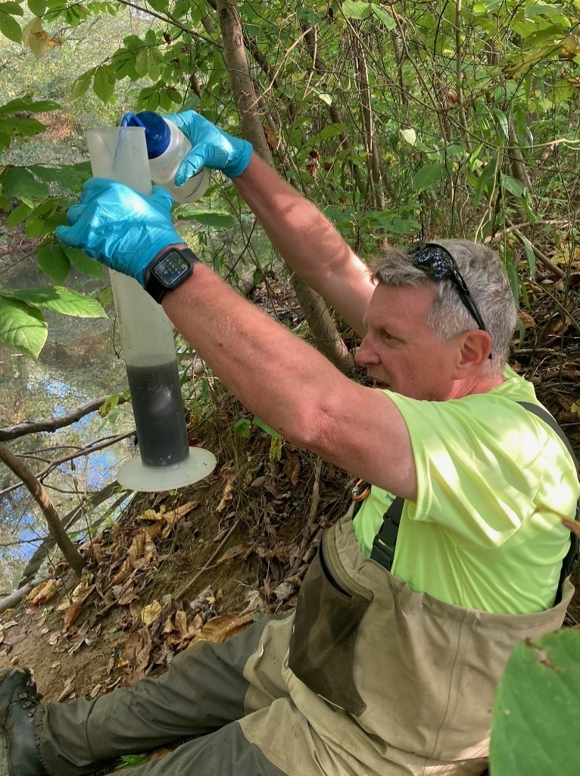

Streamside diatom sample processing in Indiana.

1. <http://www.in.gov/legislative/iac/iac_title?iact=327>
2. <https://my.usgs.gov/confluence/display/biodata/About+BioData> (diatom taxa list retrieved on February 26, 2020).
3. NWs = Mean % of lithological nitrogen (N) content in surface or near surface geology within the watershed, derived from StreamCat (Hill et al. 2016). See derivation details in Appendix A.
4. NWs = Mean % of lithological nitrogen (N) content in surface or near surface geology within the watershed, derived from StreamCat (Hill et al. 2016).
5. IDEM Diatom IBI Calculator R Shiny App: [https://tetratech-wtr-wne.shinyapps.io/IDEMtools/](https://nam10.safelinks.protection.outlook.com/?url=https%3A%2F%2Ftetratech-wtr-wne.shinyapps.io%2FIDEMtools%2F%3F_ga%3D2.105832707.1204712251.1626182602-1659294703.1616420491&data=04%7C01%7Cbenjamin.jessup%40tetratech.com%7C66dd57b8c5fe4486d97808d9460ec7bf%7Ca40fe4baabc748fe8792b43889936400%7C0%7C0%7C637617851621134791%7CUnknown%7CTWFpbGZsb3d8eyJWIjoiMC4wLjAwMDAiLCJQIjoiV2luMzIiLCJBTiI6Ik1haWwiLCJXVCI6Mn0%3D%7C1000&sdata=sq0NuZJiqj4DmTGzaYZPaywYzEdMT2ioyPvmG9YBLEA%3D&reserved=0)